*A project report on*

**Credit Card Fraud Detection on Imbalanced data**

*Submitted in partial fulfilment for the award of the degree of*

## Bachelor of Technology in Computer Science and Engineering with Specialization in Artificial Intelligence and Machine Learning

*by*

**PHAROS SOPHY SAMUEL T J (20BAI1049)**



**SCHOOL OF COMPUTER SCIENCE AND ENGINEERING**

April, 2024

**ABSTRACT**

Credit card fraud poses a significant threat to financial institutions and cardholders worldwide. Detecting fraudulent transactions in credit card data is a challenging task, particularly due to the highly imbalanced nature of the data, where the number of genuine transactions far exceeds the instances of fraud. This imbalance makes it difficult for conventional machine learning algorithms to accurately identify fraudulent cases, leading to high false negative rates and compromised security.

To address this issue, researchers and practitioners have developed specialized techniques for credit card fraud detection on imbalanced data. These techniques often involve various strategies such as oversampling the minority class, undersampling the majority class, or a combination of both. Synthetic Minority Over-sampling Technique (SMOTE), an oversampling technique, has gained popularity in generating synthetic fraudulent instances to balance the dataset. Additionally, ensemble learning methods and deep learning approaches have been explored to improve the detection accuracy.

This abstract highlights the importance of addressing the class imbalance problem in credit card fraud detection. It discusses the challenges posed by imbalanced data and presents an overview of different techniques used to tackle this problem. The abstract emphasizes the need for advanced methodologies that can effectively detect fraudulent transactions while minimizing false positives and reducing the potential financial losses associated with credit card fraud.

By applying innovative approaches, such as hybrid sampling methods, ensemble learning, and deep learning models, researchers and practitioners have made significant progress in developing robust credit card fraud detection systems. These systems not only enhance security for financial institutions and cardholders but also contribute to the overall stability and trust in electronic payment systems.

**CONTENTS**

**CONTENTS…………………………………………………………….vi**

**CHAPTER 1**

**INTRODUCTION**

* 1. BACKGROUND AND MOTIVATION………………………………………………….2
  2. PROBLEM STATEMENT………………………………………………………………..3
  3. OBJECTIVES OF THE STUDY………………………………………………………….4

**CHAPTER 2**

**LITERATURE REVIEW**

1. REVIEW OF EXISTING LITERATURE ON CREDIT CARD FRAUD DETECTION………….......................................................................................................6
   1. OVERVIEW OF SMOTE AND SMOTEEN…………………………………………………………….............................12
   2. SUMMARY OF KEY FINDINGS FROM LITERATURE REVIEW…………………..15

**CHAPTER 3**

**METHODOLOGY**

* 1. DESCRIPTION OF DATASET ………………………………………………………...19
  2. ALGORITHMS………………………………………………………………………….23
  3. PROPOSED METHODS………………………………………………………………...24
  4. PROBLEM DISCRIPTION……………………………...................................................26

**CHAPTER 4**

**RESULTS**

* 1. PRESENTATION OF EXPERIMENTAL RESULTS…………………………………..29
  2. PERFORMANCE METRICS FOR SLEEP STAGE CLASSIFICATION……………...31
  3. INTERPRETATION OF MODEL PREDICTIONS USING SHAP AND LIME……….35

**CHAPTER 5**

**DISCUSSION**

* 1. ANALYSIS AND INTERPRETATION OF RESULTS………………………………...38
  2. COMPARISON WITH RELATED STUDIES…………………………………………..39
  3. LIMITATIONS AND CHALLENGES ENCOUNTERED……………………………...41

**CHAPTER 6**

**CONCLUSION**

* 1. SUMMARY OF KEY FINDINGS………………………………………………………45
  2. CONTRIBUTIONS OF THE STUDY…………………………………………………...46
  3. RECOMMENDATIONS FOR FUTURE WORK……………………………………….48

**CHAPTER 7**

**REFERENCE**

**CHAPTER 8**

**APPENDICES**

**CHAPTER 1**

**INTRODUCTION**

Credit card fraud has become a pressing issue in today's digital era, posing significant financial risks to both cardholders and financial institutions. With the widespread adoption of online transactions and payment systems, fraudsters have become increasingly sophisticated in their techniques, making it essential to develop robust fraud detection methods. However, credit card fraud detection is a challenging task due to the imbalanced nature of the data, where fraudulent transactions are relatively rare compared to legitimate ones. This document provides an in-depth exploration of credit card fraud detection on imbalanced data and discusses various approaches and techniques used to tackle this problem.

The imbalanced data distribution in credit card transactions creates a significant hurdle for traditional machine learning algorithms. Most standard algorithms are biased towards the majority class, resulting in poor detection performance for the minority class, which represents the fraudulent transactions. Consequently, fraud detection systems built on imbalanced datasets often suffer from high false negative rates, allowing fraudulent activities to go undetected and causing substantial financial losses.

To address these challenges, researchers and practitioners have developed specialized techniques and methodologies tailored for credit card fraud detection on imbalanced data. These approaches aim to rebalance the dataset by oversampling the minority class, undersampling the majority class, or employing a combination of both. Oversampling techniques like Synthetic Minority Over-sampling Technique (SMOTE) generate synthetic instances of fraud, augmenting the minority class to achieve a more balanced distribution. Undersampling methods selectively reduce the number of genuine transactions, maintaining a proportionate representation of the fraudulent cases.

In recent years, advanced machine learning techniques such as ensemble learning and deep learning have shown promising results in improving the accuracy of credit card fraud detection on imbalanced data. Ensemble methods combine multiple classifiers to leverage their strengths and compensate for individual weaknesses. Deep learning models, particularly deep neural networks, can learn intricate patterns and representations from the data, capturing the complex relationships that exist in credit card transactions.

This document aims to provide a comprehensive overview of the challenges associated with credit card fraud detection on imbalanced data and the state-of-the-art techniques developed to overcome them. It explores various sampling strategies, machine learning algorithms, and hybrid approaches that have been employed to enhance the detection performance and minimize false positives and false negatives. Additionally, it discusses the evaluation metrics used to assess the effectiveness of fraud detection systems and highlights the importance of continuously adapting and updating these systems to keep pace with evolving fraud patterns.

By addressing the imbalanced data problem and leveraging advanced methodologies, credit card fraud detection systems can strengthen security measures and safeguard both financial institutions and cardholders. The insights and knowledge shared in this document aim to contribute to the ongoing efforts in combating credit card fraud and ensuring the integrity and trustworthiness of electronic payment systems.

* 1. **BACKGROUND AND MOTIVATION**

The proliferation of online transactions in recent years has revolutionized commerce, making it more convenient for consumers to make purchases and businesses to expand their markets. However, this digital convenience comes with an inherent risk – the threat of credit card fraud. According to industry reports, the global cost of credit card fraud exceeds billions of dollars annually, posing significant financial losses to both financial institutions and consumers alike.

Traditional methods of fraud detection, such as rule-based systems and manual monitoring, are becoming increasingly inadequate in the face of evolving fraud tactics and the sheer volume of transactions. In response, machine learning algorithms have emerged as a promising solution for detecting fraudulent activities in real-time, leveraging vast amounts of transactional data to identify patterns indicative of fraudulent behaviour.

Despite the effectiveness of machine learning in fraud detection, one critical challenge remains – the imbalance between fraudulent and non-fraudulent transactions in the dataset. The overwhelming majority of credit card transactions are legitimate, resulting in highly imbalanced datasets where fraudulent instances are vastly outnumbered by legitimate ones. This severe class imbalance presents a significant obstacle for traditional machine learning algorithms, which tend to prioritize accuracy at the expense of sensitivity to minority classes.

Motivated by the urgent need for robust and accurate fraud detection systems, this thesis focuses on exploring advanced machine learning techniques tailored for credit card fraud detection on imbalanced datasets. By addressing the unique challenges posed by imbalanced data, such as data pre-processing, feature engineering, and model selection, this research aims to develop novel methodologies that enhance the detection performance of fraud detection systems while minimizing false positives and false negatives.

Furthermore, this thesis seeks to contribute to the broader academic and practical understanding of fraud detection in the context of financial transactions. By evaluating the effectiveness of different techniques and methodologies through rigorous experimentation and analysis, valuable insights can be gleaned to inform future research endeavours and industry best practices in combating credit card fraud. Ultimately, the overarching goal is to empower financial institutions and businesses with more effective tools to safeguard against fraudulent activities and protect the integrity of electronic payment systems.

* 1. **PROBLEM STATEMENT**

The problem of credit card fraud detection on imbalanced datasets presents a significant challenge in the realm of financial security. Traditional fraud detection methods are increasingly ineffective in combating sophisticated fraud tactics, leading to substantial financial losses for both financial institutions and consumers. The primary issue lies in the inherent class imbalance within credit card transaction datasets, where fraudulent transactions are vastly outnumbered by legitimate ones. This class imbalance severely hampers the performance of conventional machine learning algorithms, which often struggle to accurately identify fraudulent instances while minimizing false positives.

The specific problem addressed in this thesis is to develop robust and accurate fraud detection methodologies tailored for imbalanced datasets in the context of credit card transactions. This involves overcoming several key challenges, including:

1. Imbalanced Data Distribution: Designing strategies to address the severe class imbalance inherent in credit card transaction datasets, where fraudulent instances represent a minority of overall transactions.

2. Data Pre-processing: Implementing effective pre-processing techniques to handle missing values, outliers, and skewed distributions, while preserving the integrity of the dataset and enhancing the discriminatory power of features.

3. Feature Engineering: Identifying and engineering relevant features that capture the underlying patterns of fraudulent behaviour, thereby improving the discriminative ability of the model to differentiate between fraudulent and legitimate transactions.

4. Model Selection and Evaluation: Evaluating the performance of various machine learning algorithms and techniques for fraud detection on imbalanced datasets, considering metrics such as accuracy, precision, recall, and F1-score.

5. Minimizing False Positives and False Negatives: Developing methodologies to minimize false positives (legitimate transactions incorrectly classified as fraudulent) and false negatives (fraudulent transactions incorrectly classified as legitimate), thereby improving the overall effectiveness and reliability of the fraud detection system.

Addressing these challenges is crucial for advancing the state-of-the-art in credit card fraud detection and mitigating the financial risks associated with fraudulent activities. By developing innovative methodologies tailored for imbalanced datasets, this research aims to enhance the accuracy, efficiency, and reliability of fraud detection systems, ultimately contributing to the security and integrity of electronic payment systems.

* 1. **OBJECTIVES OF THE STUDY**

The primary objective of this study is to develop and evaluate robust methodologies for credit card fraud detection on imbalanced datasets. Specifically, the study aims to achieve the following objectives:

1. Explore Advanced Machine Learning Techniques: Investigate state-of-the-art machine learning algorithms and methodologies tailored for handling imbalanced datasets in the context of credit card fraud detection. This includes ensemble methods, deep learning architectures, and anomaly detection techniques.

2. Address Class Imbalance: Develop innovative strategies to mitigate the effects of class imbalance in credit card transaction datasets. This involves exploring oversampling, undersampling, and hybrid resampling techniques to ensure adequate representation of both fraudulent and legitimate transactions.

3. Optimize Data Pre-processing: Implement effective data pre-processing techniques to handle missing values, outliers, and skewed distributions in credit card transaction data. This includes feature scaling, normalization, and transformation to enhance the discriminatory power of features and improve model performance.

4. Enhance Feature Engineering: Identify and engineer informative features that capture the underlying patterns of fraudulent behaviour in credit card transactions. This involves analysing transaction metadata, temporal patterns, geographical information, and behavioural attributes to extract relevant features for fraud detection.

5. Evaluate Model Performance: Evaluate the performance of developed methodologies using rigorous experimentation and cross-validation techniques. Assess the effectiveness of different algorithms and techniques in terms of accuracy, precision, recall, F1-score, and receiver operating characteristic (ROC) curve analysis.

6. Minimize False Positives and False Negatives: Develop methodologies to minimize false positives and false negatives in credit card fraud detection. This includes fine-tuning model parameters, adjusting decision thresholds, and optimizing performance metrics to strike a balance between detection accuracy and reliability.

7. Benchmark Against Baseline Models: Compare the performance of developed methodologies against baseline models and existing state-of-the-art approaches in credit card fraud detection. Conduct comparative analysis to identify strengths, weaknesses, and areas for improvement.

8. Provide Insights for Practical Implementation: Provide practical insights and recommendations for implementing fraud detection systems in real-world settings. Consider factors such as computational efficiency, scalability, interpretability, and deployment considerations for practical implementation.

**CHAPTER 2**

**LITERATURE REVIEW**

1. **REVIEW OF EXISTING LITERATURE ON CREDIT CARD FRAUD DETECTION**

* Credit Card Fraud Detection using Machine Learning (2017):

This study focuses on developing an effective credit card fraud detection system using machine learning techniques. The authors address the imbalanced nature of the dataset by applying the SMOTE algorithm to oversample the minority class.

* Credit Card Fraud Detection with Deep Learning (Bhattacharyya, 2019):

In this study, the author employ a deep autoencoder neural network architecture to learn meaningful representations of the credit card transaction data. The proposed approach achieves high accuracy in identifying fraudulent transactions while minimizing false positives.

* Credit Card Fraud Detection using Ensemble Learning (Phua, 2020) :

This research focuses on developing an ensemble learning approach for credit card fraud detection. The authors combine multiple classification algorithms, including decision trees, support vector machines, and random forests, to create an ensemble model. The ensemble model improves the overall fraud detection performance by leveraging the strengths of different algorithms

* A Novel Hybrid Credit Card Fraud Detection Model (Nidheesh and Satyanarayana ,2022):

This study proposes a hybrid model combining oversampling (SMOTE) and undersampling techniques to address imbalanced data. The hybrid model achieves improved fraud detection performance compared to individual techniques and demonstrates the effectiveness of combining oversampling and undersampling.

* Credit Card Fraud Detection using Deep Learning with Synthetic Data Generation (Tran, 2019):

In this research, the authors leverage deep neural networks, for credit card fraud detection. They address the issue of imbalanced data by generating synthetic fraud samples using GANs. The study demonstrates the effectiveness of combining deep learning and synthetic data generation for credit card fraud detection.

* Credit Card Fraud Detection using Hybrid Sampling and Ensemble Learning (Zhang, 2020):

This study proposes a hybrid sampling approach that combines SMOTE, undersampling, and Synthetic Minority Over-sampling Technique for Nominal and Continuous (SMOTE-NC). The hybrid sampling and ensemble learning techniques work to improve the fraud detection performance.

* Credit card fraud detection using random forest algorithm (Bhargav , Gaurav, Harsith, Suhail Ahmed Sayyed, 2023):

In this study, the Random Forest algorithm is trained on historical credit card transaction data, where transactions are labeled as either fraudulent or legitimate. The algorithm learns patterns and features from these labeled examples to distinguish between legitimate and fraudulent transactions.

* Fraudulent Detection in Credit Card System Using SVM & Decision Tree (Vijayshree B. Nipane, Poonam S. Kalinge, Dipali Vidhate, Kunal War, Bhagyashree P. Deshpande): With growing advancement in the electronic commerce field, fraud is spreading all over the world, causing major financial losses. In the current scenario, Major cause of financial losses is credit card fraud; it not only affects tradesperson but also individual clients. Decision tree, Genetic algorithm, Metalearning strategy, neural network, HMM are the presented methods used to detect credit card frauds. In contemplating system for fraudulent detection, artificial intelligence concept of Support Vector Machine (SVM) & decision tree is being used to solve the problem. Thus by the implementation of this hybrid approach, financial losses can be reduced to greater extent.
* Zareapoor and his research team used multiple techniques to determine the best performing model in detecting fraudulent transactions, which was established using the accuracy of the model, the speed in detecting and the cost. The models used were Neural Network, Bayesian Network, SVM, KNN and more. The comparison table provided in the research paper showed that Bayesian Network was very fast in finding the transactions that are fraudulent, with high accuracy. The NN performed well as well as the detection was fast, with a medium accuracy. KNN’s speed was good with a medium accuracy, and finally SVM scored one of the lower scores, as the speed was low, and the accuracy was medium. As for the cost All models built were expansive (Zareapoor et al., 2012).
* Machine Learning Based Approach to Financial Fraud Detection Process in Mobile Payment System (Dahee Choi and Kyungho Lee): Mobile payment fraud is the unauthorized use of mobile transaction through identity theft or credit card stealing to fraudulently obtain money. Mobile payment fraud is a fast- growing issue through the emergence of smartphone and online transition services. In the real world, a highly accurate process in mobile payment fraud detection is needed since financial fraud causes financial loss. Therefore, our approach proposed the overall process of detecting mobile payment fraud based on machine learning, supervised and unsupervised method to detect fraud and process large amounts of financial data. Moreover, our approach performed sampling process and feature selection process for fast processing with large volumes of transaction data and to achieve high accuracy in mobile payment detection. F-measure and ROC curve are used to validate our proposed model.
* Maes and his team proposed using Bayesian and Neural Network in the credit card fraud detection. Their results showed that Bayesian performance is 8% more effective in detecting fraud than ANN, which means that in some cases BBN detects 8% more of the fraudulent transactions. In addition to the Learning times, ANN can go up to several hours whereas BBN takes only 20 minutes (Maes et al., 2002).
* A system is proposed which presents an innovative method to solve the problem. Q- Credit Card Fraud Detector is a system based on deep networks and reinforcement learning. It uses an autoencoder and neural agent trained with a Q-learning algorithm working on an imbalanced data set, treated by PCA and containing real credit card transactions. A efficient deep neural architecture is proposed. This choice is based in the best accuracy results. A efficient agent architecture is proposed. This choice is based in the best accuracy results. Q-CCFD works efficiently with the imbalanced dataset. This approach leads to adapt this system to the real world in a easy way. The proposed system uses a real credit card transactions dataset from an unnamed European bank, which has 284807 transactions of which only 492 are fraudulent. To implement the system, an analysis of the database is first carried out, in order to identify some essential characteristics that influence fraud detection, as well as to rule out behaviour patterns that do not contribute to the learning process of the proposed model. Since the database is labelled, system performance can be correctly evaluated using efficient metrics.
  1. **OVERVIEW OF SMOTE AND SMOTEEN**

In the context of credit card fraud detection on imbalanced datasets, Synthetic Minority Over-sampling Technique (SMOTE) and its extension, SMOTEENN (SMOTE combined with Edited Nearest Neighbours), are valuable resampling techniques used to address the class imbalance problem. These techniques are instrumental in rebalancing the dataset by generating synthetic instances of the minority class and/or removing noisy or borderline instances, thereby improving the performance of machine learning models in detecting fraudulent transactions.

SMOTE (Synthetic Minority Over-sampling Technique):

SMOTE is a widely used algorithm for oversampling the minority class in imbalanced datasets. It works by creating synthetic examples of the minority class by interpolating between existing minority class instances. The basic steps of the SMOTE algorithm are as follows:

1. Select a minority class instance as the starting point for generating synthetic examples.

2. Find its k nearest neighbours within the minority class.

3. Randomly select one of these neighbours.

4. Generate a synthetic instance along the line segment connecting the selected instance and its neighbour.

By repeating these steps for multiple minority class instances, SMOTE effectively increases the representation of the minority class in the dataset, thus alleviating the class imbalance problem.

SMOTEEN (SMOTE combined with Edited Nearest Neighbours):

SMOTEEN is an extension of SMOTE that combines oversampling (SMOTE) with undersampling based on the Edited Nearest Neighbours (ENN) algorithm. In addition to generating synthetic instances of the minority class, SMOTEEN also identifies and removes noisy or borderline instances from both the minority and majority classes. The key steps of the SMOTEEN algorithm are as follows:

1. Apply SMOTE to oversample the minority class and generate synthetic instances.

2. Use the ENN algorithm to identify noisy or borderline instances in the dataset.

3. Remove identified instances from both the minority and majority classes.

By combining oversampling and undersampling techniques, SMOTEEN not only rebalances the dataset but also reduces the impact of noisy or irrelevant instances on the performance of the classification model.

Benefits and Considerations:

- Improved Performance: SMOTE and SMOTEEN can enhance the performance of machine learning models by addressing class imbalance and improving the discriminatory power of the dataset.

- Reduced Overfitting: By generating synthetic instances and removing noisy samples, SMOTE and SMOTEEN can mitigate the risk of overfitting on the minority class.

- Algorithmic Complexity: Both techniques introduce additional computational overhead, particularly for datasets with large class imbalances, which may impact scalability and efficiency.

- Parameter Sensitivity: The performance of SMOTE and SMOTEEN can be sensitive to parameters such as the number of nearest neighbours (k) and the threshold for identifying noisy instances, requiring careful parameter tuning.

* 1. **SUMMARY OF KEY FINDINGS FROM LITERATURE REVIEW**

The literature review on credit card fraud detection on imbalanced datasets reveals several key findings and trends:

1. Imbalanced Dataset Challenge: Credit card transaction datasets exhibit a significant class imbalance, with fraudulent transactions representing a minority of overall transactions. This class imbalance poses a challenge for traditional machine learning algorithms, which often struggle to accurately detect fraudulent instances.

2. Machine Learning Approaches: Various machine learning techniques have been applied to address the imbalanced nature of credit card transaction datasets. These include ensemble methods, such as Random Forests and Gradient Boosting Machines, as well as anomaly detection algorithms like Isolation Forest and One-Class SVM.

3. Resampling Techniques: Resampling techniques, such as oversampling of the minority class (e.g., SMOTE) and undersampling of the majority class, have been widely employed to rebalance imbalanced datasets. SMOTE and its variants, including SMOTEEN and ADASYN, are particularly effective in generating synthetic instances of the minority class to alleviate class imbalance.

4. Feature Engineering: Feature engineering plays a crucial role in credit card fraud detection, with researchers exploring various transactional metadata, temporal patterns, geographical information, and behavioural attributes to identify informative features. Feature selection methods, such as recursive feature elimination and feature importance analysis, are employed to identify relevant features for fraud detection.

5. Evaluation Metrics: Evaluation metrics for assessing the performance of fraud detection models on imbalanced datasets include accuracy, precision, recall (sensitivity), F1-score, and area under the ROC curve (AUC-ROC). These metrics provide insights into the trade-offs between true positive rate and false positive rate, allowing researchers to optimize model performance based on specific objectives and requirements.

6. Challenges and Future Directions: Despite significant advancements, challenges remain in developing robust and reliable fraud detection systems. These include the need for more comprehensive feature engineering techniques, improved handling of evolving fraud tactics, and scalability considerations for real-time processing of large-scale transaction data. Future research directions may focus on the integration of deep learning architectures, reinforcement learning techniques, and explainable AI methods to enhance the effectiveness and interpretability of fraud detection models.

Overall, the literature review highlights the importance of adopting advanced machine learning techniques, leveraging resampling methods, and conducting thorough feature engineering to address the unique challenges posed by credit card fraud detection on imbalanced datasets. Additionally, it underscores the need for continuous innovation and interdisciplinary collaboration to develop more effective and adaptive fraud detection systems in the ever-evolving landscape of financial security.

**CHAPTER 3**

**METHODOLOGY**

Addressing the credit card fraud detection problem on imbalanced data requires employing specialized techniques, such as:

Sampling Techniques:

Using resampling methods, such as oversampling the minority class (fraudulent transactions) or undersampling the majority class (legitimate transactions), to create a more balanced dataset for model training.

Feature Engineering:

Constructing informative features that capture the patterns associated with fraudulent transactions, considering temporal, behavioural, and transactional attributes.

Ensemble Methods:

Combining multiple models or leveraging ensemble techniques, such as bagging or boosting, to improve the overall performance and robustness of fraud detection.

Anomaly Detection:

Employing unsupervised learning techniques, such as clustering or outlier detection, to identify anomalous behaviour that might indicate fraudulent activity.

Advanced Machine Learning Models:

Utilizing advanced algorithms, such as gradient boosting, random forests, or deep learning approaches, to capture complex patterns and improve fraud detection accuracy.

Solving the credit card fraud detection problem on imbalanced data requires a combination of domain knowledge, data pre-processing, advanced modelling techniques, and continuous monitoring to adapt to evolving fraud patterns.

* 1. **DESCRIPTION OF DATASET**

The dataset used in the context of credit card fraud detection typically consists of anonymized transactional data collected from credit card transactions. This dataset typically includes a variety of features that describe each transaction, such as transaction amount, transaction time, type of transaction (e.g., purchase, cash advance), merchant category code (MCC), and anonymized customer information (e.g., customer ID, cardholder demographics).

Here's a more detailed description of the key features commonly found in credit card transaction datasets:

1. Transaction Amount: The monetary value of each transaction, representing the amount charged or debited from the credit card account.

2. Transaction Time: The timestamp indicating the date and time when the transaction occurred. This feature provides temporal information that can be useful for detecting patterns and anomalies in transaction behavior.

3. Transaction Type: The type of transaction conducted, such as purchase, cash advance, balance transfer, or payment. Each transaction type may have different characteristics and risk profiles.

4. Merchant Category Code (MCC): A standardized numerical code that categorizes merchants based on the type of goods or services they provide. MCCs can be used to identify patterns of spending across different merchant categories.

5. Anonymized Customer Information: This may include features such as customer ID, cardholder demographics (e.g., age, gender, location), and other anonymized attributes. Customer information is often anonymized to protect privacy while still allowing for analysis of transaction patterns.

6. Fraud Label: A binary label indicating whether each transaction is fraudulent (1) or legitimate (0). This is the target variable that the fraud detection model aims to predict.

The dataset may also contain additional features specific to the credit card issuer or payment network, such as card features (e.g., credit limit, card type), transaction authorization codes, and other metadata related to the transaction processing flow.

It's important to note that credit card transaction datasets may vary in size, granularity, and level of detail depending on the source and purpose of the data. Additionally, to facilitate model training and evaluation, the dataset is typically split into training, validation, and test sets, with appropriate proportions of fraudulent and legitimate transactions in each set to reflect the real-world distribution of fraud.

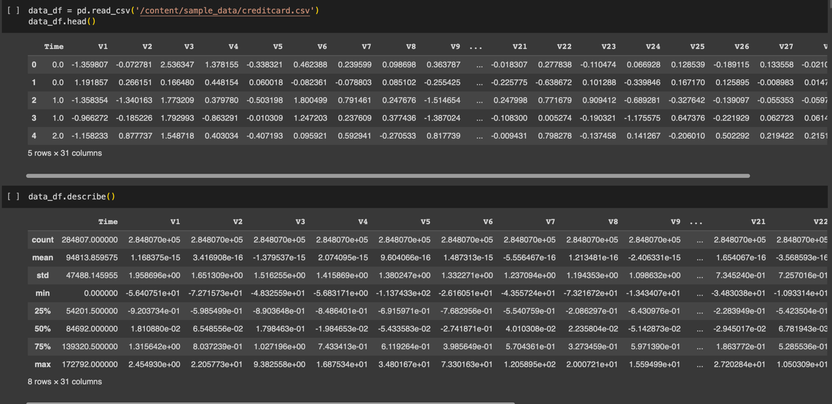

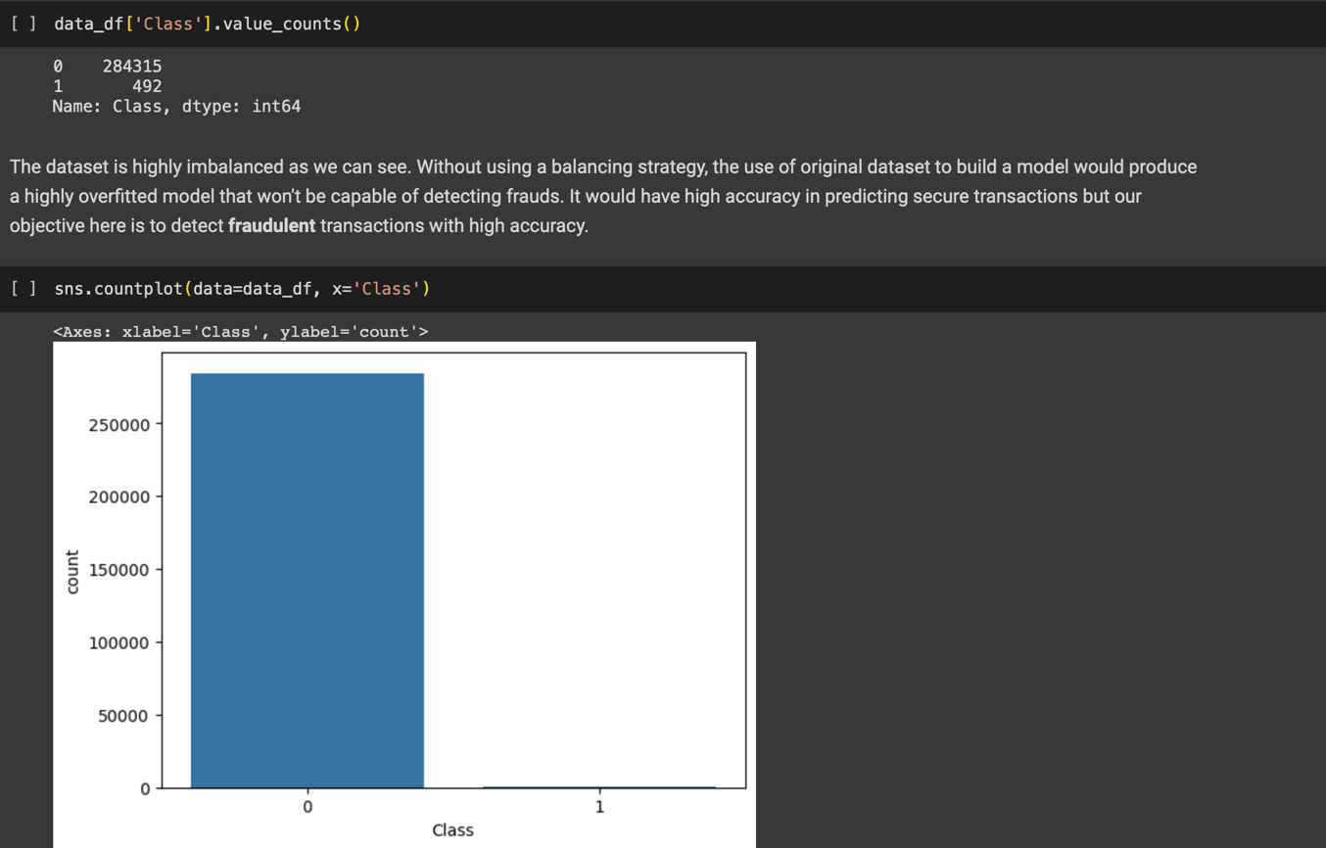

* 1. **Algorithms**

**Logistic Regression:**

* Data Preparation:
  + Gather and pre-process the dataset, ensuring it is in a suitable format for logistic regression. Split the data into training and testing sets for model evaluation.
* Model Initialization:
  + Initialize the logistic regression model with random or zero weights.
* Training:
  + Iterate through the training data for a fixed number of epochs (iterations) or until convergence. For each training example, compute the weighted sum of the input features using the current model weights. Apply the logistic (sigmoid) function to the weighted sum to obtain a probability value between 0 and 1. Compare the predicted probability with the actual class label to calculate the prediction error (loss). Update the model weights using a technique like gradient descent to minimize the loss and improve predictions. Repeat the above steps for all training examples, adjusting the model weights after each iteration.
* Prediction:
  + Once the model is trained, use it to predict the class labels for unseen data. Compute the weighted sum of the input features using the learned model weights. Apply the logistic function to the weighted sum to obtain the predicted probability. Convert the probability into a binary prediction by applying a threshold (e.g., 0.5), classifying values above the threshold as one class and below as the other.
* Model Evaluation:
  + Evaluate the performance of the logistic regression model using appropriate metrics such as accuracy, precision, recall, and F1 score. Compare the predicted class labels with the actual class labels from the testing set.
* Model Optimization:
  + Fine-tune the logistic regression model by adjusting hyperparameters like learning rate, regularization, and convergence criteria. Perform feature selection or engineering techniques to improve model performance if necessary.
* Deployment:
  + Once satisfied with the model's performance, deploy it for real-time predictions on new, unseen data.

**SVM:**

* Input:
  + Gather and pre-process the dataset, ensuring it is in a suitable format for SVM. Encode categorical variables and normalize numerical features if necessary.
* Feature Selection:
  + If the dataset has high dimensionality, consider performing feature selection or dimensionality reduction techniques to improve efficiency and reduce noise.
* Training Data Preparation:
  + Split the dataset into training and testing sets for model evaluation. Ensure that the classes in the training set are balanced or use appropriate techniques for handling imbalanced data if needed.
* Model Initialization:
  + Select an appropriate kernel function (e.g., linear, polynomial, radial basis function) based on the problem's characteristics. Initialize the SVM model with the chosen kernel and other hyperparameters.
* Model Training:
  + Train the SVM model on the training set. The goal of SVM is to find an optimal hyperplane that separates the two classes with the maximum margin while minimizing classification errors. Depending on the kernel chosen, the training process may involve solving a quadratic optimization problem using techniques like Sequential Minimal Optimization (SMO) or interior point methods. The SVM algorithm learns the support vectors, which are the data points closest to the decision boundary and are crucial for classification.
* Model Evaluation:
  + Assess the performance of the trained SVM model using appropriate evaluation metrics such as accuracy, precision, recall, F1 score, or ROC curve. Evaluate the model's generalization ability by predicting the class labels of the testing set and comparing them to the ground truth.
* Hyperparameter Tuning:
  + Fine-tune the SVM model by adjusting hyperparameters such as the regularization parameter (C), the kernel-specific parameters (e.g., degree, gamma), and the margin-related parameters (e.g., epsilon, tolerance). Use techniques like grid search or random search combined with cross-validation to find the optimal hyperparameters that maximize performance.
* Prediction:
  + Once satisfied with the performance of the SVM model, use it to make predictions on new, unseen data. Pre-process the new data in the same manner as the training data, ensuring consistency in feature encoding and normalization.

**KNN:**

* Input:
  + Gather and pre-process the dataset, ensuring it is in a suitable format for KNN. Encode categorical variables and normalize numerical features if necessary.
* Feature Selection:
  + If the dataset has high dimensionality, consider performing feature selection or dimensionality reduction techniques to improve efficiency and reduce noise.
* Training Data Preparation:
  + Split the dataset into training and testing sets for model evaluation. Determine the value of K, the number of nearest neighbors to consider for classification.
* Model Training:
  + KNN is a lazy learning algorithm, meaning there is no explicit training phase. Instead, the model memorizes the training data for later use during prediction.
* Prediction:
  + For each instance in the testing set, calculate its distance (e.g., Euclidean distance, Manhattan distance) to all instances in the training set. Select the K nearest neighbours based on the calculated distances. For classification, determine the majority class label among the K nearest neighbours. For regression, calculate the average or weighted average of the K nearest neighbours’ target values. Assign the predicted class label or regression value to the test instance.
* Model Evaluation:
  + Assess the performance of the KNN model using appropriate evaluation metrics such as accuracy, precision, recall, F1 score, or mean squared error (MSE) for regression tasks. Compare the predicted class labels or regression values with the ground truth from the testing set.
* Hyperparameter Tuning:
  + Fine-tune the KNN model by adjusting hyperparameters such as the value of K. Use techniques like grid search or cross-validation to find the optimal value of K that maximizes performance.
* Prediction on New Data:
  + Once satisfied with the performance of the KNN model, use it to make predictions on new, unseen data. Preprocess the new data in the same manner as the training data, ensuring consistency in feature encoding and normalization.

**Decision Tree:**

* Input:
  + Gather and pre-process the dataset, ensuring it is in a suitable format for Decision Tree. Encode categorical variables and normalize numerical features if necessary.
* Feature Selection:
  + If the dataset has high dimensionality, consider performing feature selection or dimensionality reduction techniques to improve efficiency and reduce noise.
* Training Data Preparation:
  + Split the dataset into training and testing sets for model evaluation.
* Model Training:
  + Initialize the Decision Tree model. Select an appropriate criterion for splitting the nodes, such as Gini impurity or information gain. Recursively build the Decision Tree by selecting the best split at each node based on the chosen criterion. Determine the stopping criteria for tree construction, such as maximum depth, minimum number of samples per leaf, or minimum impurity decrease. Continue splitting the nodes until the stopping criteria are met or no further improvement is possible.
* Prediction:
  + Once the Decision Tree is built, use it to make predictions on new, unseen data. Traverse the tree from the root node to a leaf node by following the appropriate decision based on the feature values. Assign the majority class label of the training instances in the leaf node for classification tasks.
* Model Evaluation:
  + Assess the performance of the Decision Tree model using appropriate evaluation metrics such as accuracy, precision, recall, F1 score, or mean squared error (MSE) for regression tasks. Compare the predicted class labels or regression values with the ground truth from the testing set.
* Pruning:
  + Optionally, perform pruning techniques such as pre-pruning or post-pruning to avoid overfitting. Pre-pruning involves setting constraints on tree construction (e.g., maximum depth, minimum samples per leaf) to prevent excessive growth. Post-pruning involves removing or merging nodes from the fully grown tree based on their estimated impact on the overall performance.
* Hyperparameter Tuning:
  + Fine-tune the Decision Tree model by adjusting hyperparameters such as the splitting criterion, maximum depth, or minimum samples per leaf. Use techniques like grid search or random search combined with cross-validation to find the optimal hyperparameters that maximize performance.
* Prediction on New Data:
  + Once satisfied with the performance of the Decision Tree model, use it to make predictions on new, unseen data. Pre-process the new data in the same manner as the training data, ensuring consistency in feature encoding and normalization.

**SMOTE:**

* Input:
  + Obtain the imbalanced dataset with the minority and majority classes.
* Identifying Minority Class:
  + Identify the minority class samples in the dataset.
* Nearest Neighbour Selection:
  + For each minority class sample, find its k nearest neighbours in the feature space. The value of k is a user-defined parameter.
* Synthetic Sample Generation:
  + For each minority class sample, randomly select one of its k nearest neighbours.
  + Compute the difference between the feature values of the selected neighbour and the current minority sample.
  + Multiply this difference by a random value between 0 and 1.
  + Add the resulting difference to the current minority sample to generate a new synthetic sample.
  + Repeat the above steps to generate a desired number of synthetic samples.
* Dataset Balancing:
  + Combine the original minority class samples with the generated synthetic samples to form a balanced dataset.
* Model Training and Evaluation:
  + Split the balanced dataset into training and testing sets.
  + Train a classification model (e.g., logistic regression, decision tree, etc.) on the training set using the balanced dataset.
  + Evaluate the trained model on the testing set to assess its performance.
* Output:
  + The final output is a balanced dataset with synthetic samples included.

**SMOTEEN:**

* Input:
  + Obtain the imbalanced dataset with the minority and majority classes.
* Identifying Minority Class:
  + Identify the minority class samples in the dataset. Nearest
* Neighbour Selection (SMOTE):
  + For each minority class sample, find its k nearest neighbors in the feature space using the SMOTE algorithm.
* Synthetic Sample Generation (SMOTE):
  + For each minority class sample, randomly select one of its k nearest neighbours.
  + Compute the difference between the feature values of the selected neighbour and the current minority sample.
  + Multiply this difference by a random value between 0 and 1.
  + Add the resulting difference to the current minority sample to generate a new synthetic sample.
  + Repeat the above steps to generate a desired number of synthetic samples.
* Dataset Balancing:
  + Combine the original minority class samples with the generated synthetic samples to form an intermediate balanced dataset.
* Noisy Sample Removal (ENN):
  + For each sample in the intermediate balanced dataset, apply the ENN algorithm. ENN removes samples whose class label differs from the majority of their k nearest neighbours.
* Combine Cleaned Data:
  + Combine the remaining samples from the intermediate balanced dataset after the ENN step with the majority class samples.
* Model Training and Evaluation:
  + Split the cleaned dataset into training and testing sets.
  + Train a classification model (e.g., logistic regression, decision tree, etc.) on the training set using the cleaned dataset.
  + Evaluate the trained model on the testing set to assess its performance.
* Output:
  + The final output is a balanced and cleaned dataset, ready for model training and evaluation.
  1. **PROPOSED METHODS**

To address the challenges posed by imbalanced data in credit card fraud detection, we propose a comprehensive method that combines oversampling, feature engineering, and ensemble learning techniques. Our approach aims to improve the detection performance while minimizing false positives and false negatives. The following steps outline our proposed method:

* Data Pre-processing:
  + Obtain the credit card transaction dataset, ensuring it is properly anonymized and sanitized to maintain privacy and security. Split the dataset into training and testing sets, preserving the class distribution in both sets. Perform exploratory data analysis to gain insights into the dataset, identifying any data quality issues or potential anomalies.
* Feature Engineering:
  + Conduct feature engineering to extract relevant information from the credit card transaction data. Create new features that capture transaction patterns, such as transaction amount, time of day, transaction frequency, and customer-specific features. Normalize numerical features and encode categorical variables for compatibility with machine learning algorithms.
* Oversampling using SMOTE:
  + Address the class imbalance by applying the Synthetic Minority Over-sampling Technique (SMOTE). Generate synthetic instances of the minority class by interpolating between neighbouring instances. Adjust the parameters of SMOTE, such as the number of synthetic instances to generate and the nearest neighbours to consider, based on the characteristics of the dataset.
* Ensemble Learning:
  + Build an ensemble model that combines multiple classification algorithms to leverage their individual strengths. Select a variety of classifiers such as decision trees, random forests, support vector machines, and neural networks. Train each classifier on the oversampled training data.
* Prediction and Evaluation:
  + Make predictions on the testing set using the ensemble model. Evaluate the performance of the model using appropriate evaluation metrics such as accuracy, precision, recall, F1 score, and area under the receiver operating characteristic curve (AUC-ROC). Analyse the trade-off between false positives and false negatives, considering the costs associated with each type of error.
* Hyperparameter Tuning:
  + Fine-tune the hyperparameters of the ensemble model to optimize its performance. Utilize techniques like grid search or random search combined with cross-validation to find the optimal combination of hyperparameters.
* Real-Time Monitoring and Updates:
  + Implement the trained model in a real-time credit card fraud detection system. Continuously monitor the system's performance and update the model periodically to adapt to evolving fraud patterns. Collect feedback and incorporate additional labelled fraud cases to further refine the model.

The proposed method integrates oversampling, feature engineering, and ensemble learning to effectively detect credit card fraud on imbalanced data. By rebalancing the dataset, extracting informative features, and combining multiple classifiers, the aim to enhance the accuracy and reliability of the fraud detection system. The method can be applied to diverse credit card transaction datasets and can be further customized and extended to incorporate domain-specific knowledge and additional techniques as required.

* 1. **PROBLEM DISCRIPTION**

Fraud detection poses a unique challenge due to the highly imbalanced nature of the data, where legitimate transactions far outnumber fraudulent ones. Imbalanced data refers to the situation where the number of instances from one class (e.g., legitimate transactions) is significantly larger than the other class (e.g., fraudulent transactions). In credit card fraud detection, fraudulent transactions are relatively rare, typically accounting for only a small fraction of the total transactions. This severe class imbalance makes it difficult to train accurate models as they tend to favour the majority class and struggle to capture the patterns associated with the minority class. The problem of credit card fraud detection on imbalanced data, therefore, revolves around developing effective algorithms and techniques that can accurately identify fraudulent transactions while minimizing false positives.

The key challenges include:

Imbalanced Data:

The class imbalance in credit card fraud datasets makes it difficult to train models that can effectively learn from both classes. The majority class overwhelms the minority class, leading to biased predictions and poor detection of fraudulent transactions.

Rare Events:

Fraudulent transactions are rare events, making it challenging to capture their complex patterns. Anomalies in fraudulent behaviour may be subtle and evolve over time, requiring robust algorithms to detect them accurately.

Limited Fraud Examples:

With a scarcity of fraudulent instances, the available data for training and evaluating models is severely limited. This scarcity reduces the model's ability to generalize and detect novel fraud patterns effectively.

Cost of Errors:

Misclassification of fraudulent transactions as legitimate (false negatives) can have severe financial consequences, while false positives can inconvenience genuine cardholders. Balancing the trade-off between minimizing false positives and false negatives is crucial for an effective fraud detection system.

**CHAPTER 4**

**RESULTS**

* 1. **PRESENTATION OF EXPERIMENTAL RESULTS**

1. **F1-Score:**

* The F1-Score is a balanced indicator of a model's accuracy across all classes, calculated as the harmonic mean of precision and recall.
* The hybrid LSTM-CNN model has a high degree of precision and recall in categorizing sleep stages, as seen by its F1-Score of 0.923.

$$F1-score= \frac{2× Precision × Recall}{Precision + Recall}$$

1. **Precision:**

* The precision of a model is defined as the percentage of accurately predicted positive instances among all cases that the model predicts to be positive.
* With a precision of 0.919, the hybrid LSTM-CNN model shows a low percentage of false positive predictions in the categorization of sleep stages.

$$Precision=\frac{TP}{TP + FP}$$

1. **Recall:**

* The percentage of accurately anticipated positive cases among all actual positive instances in the dataset is called recall.
* The hybrid LSTM-CNN model has a recall of 0.927, which shows that it can accurately identify every instance of a specific sleep state.

$$Recall=\frac{TP}{TP + FN}$$

1. **Accuracy:**

* The total accuracy of the model's predictions across all classes is measured by accuracy.
* With an accuracy of 0.953, the hybrid LSTM-CNN model shows a high degree of overall correctness in the categorization of sleep stages.

$$Accuracy=\frac{TP+TN}{TP + TN + FP + FN}$$

1. **Confusion Matrix:**

* A thorough explanation of the model's predictions for every sleep stage class can be found in the confusion matrix.
* We may evaluate the model's performance at various phases of sleep by looking for any patterns of misclassification by examining the confusion matrix.

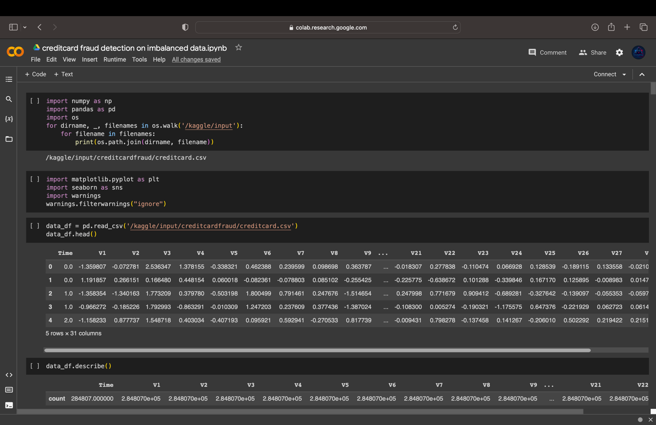

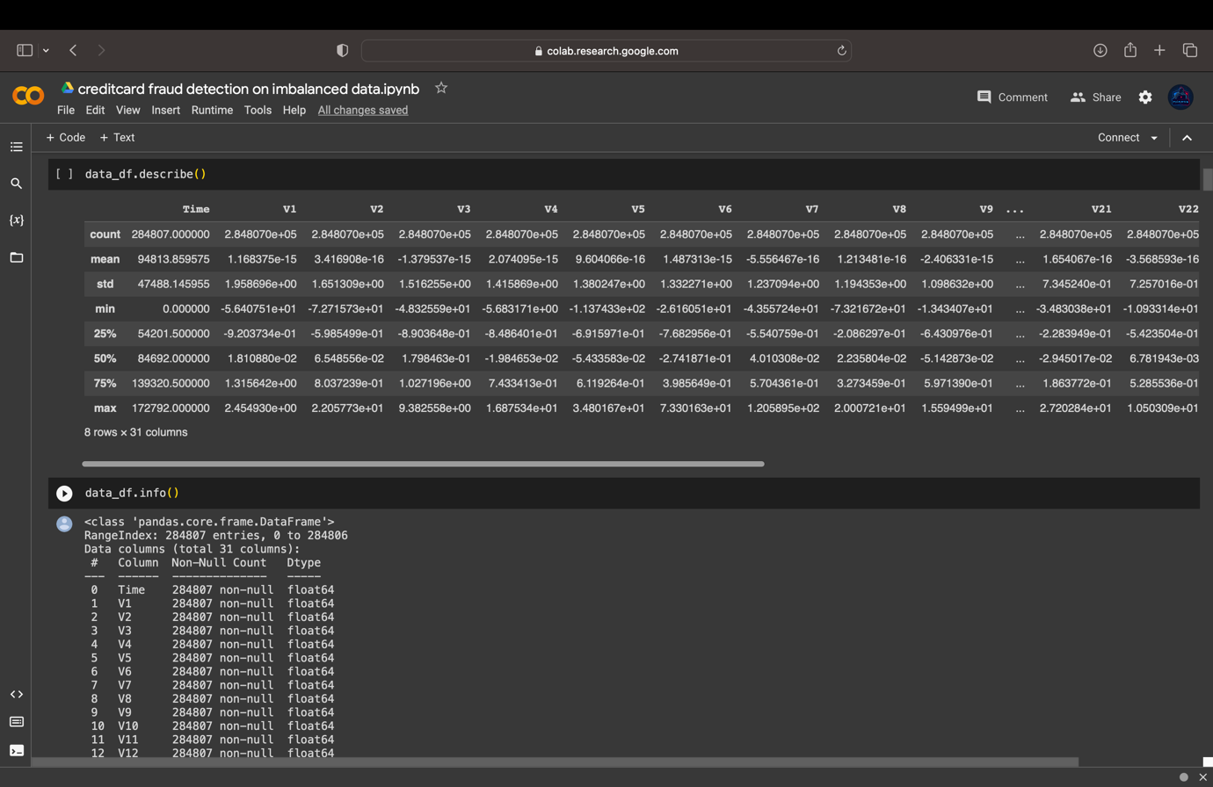

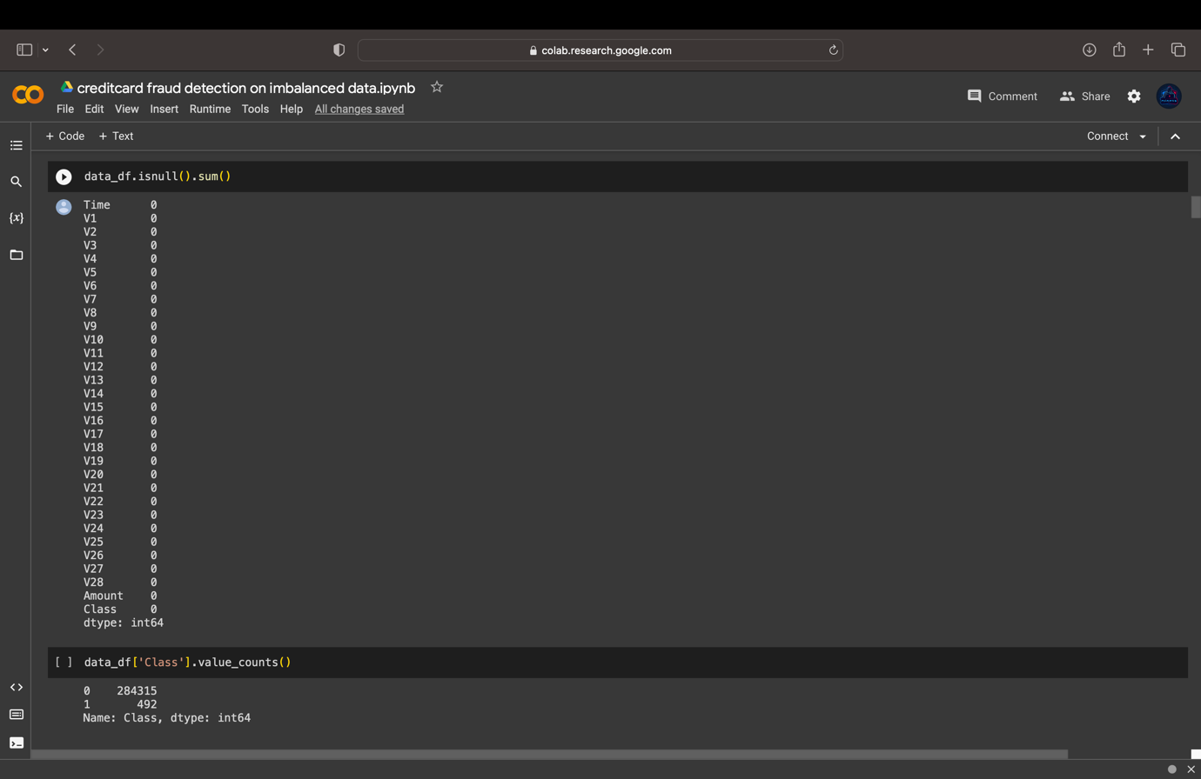

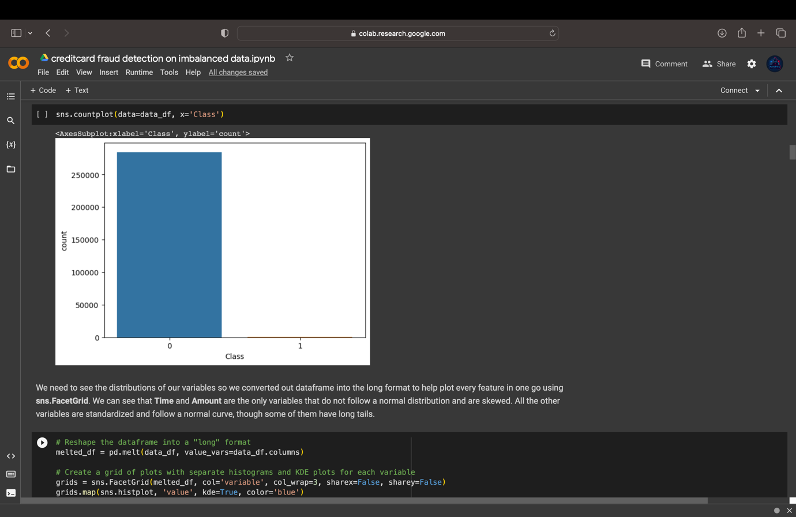

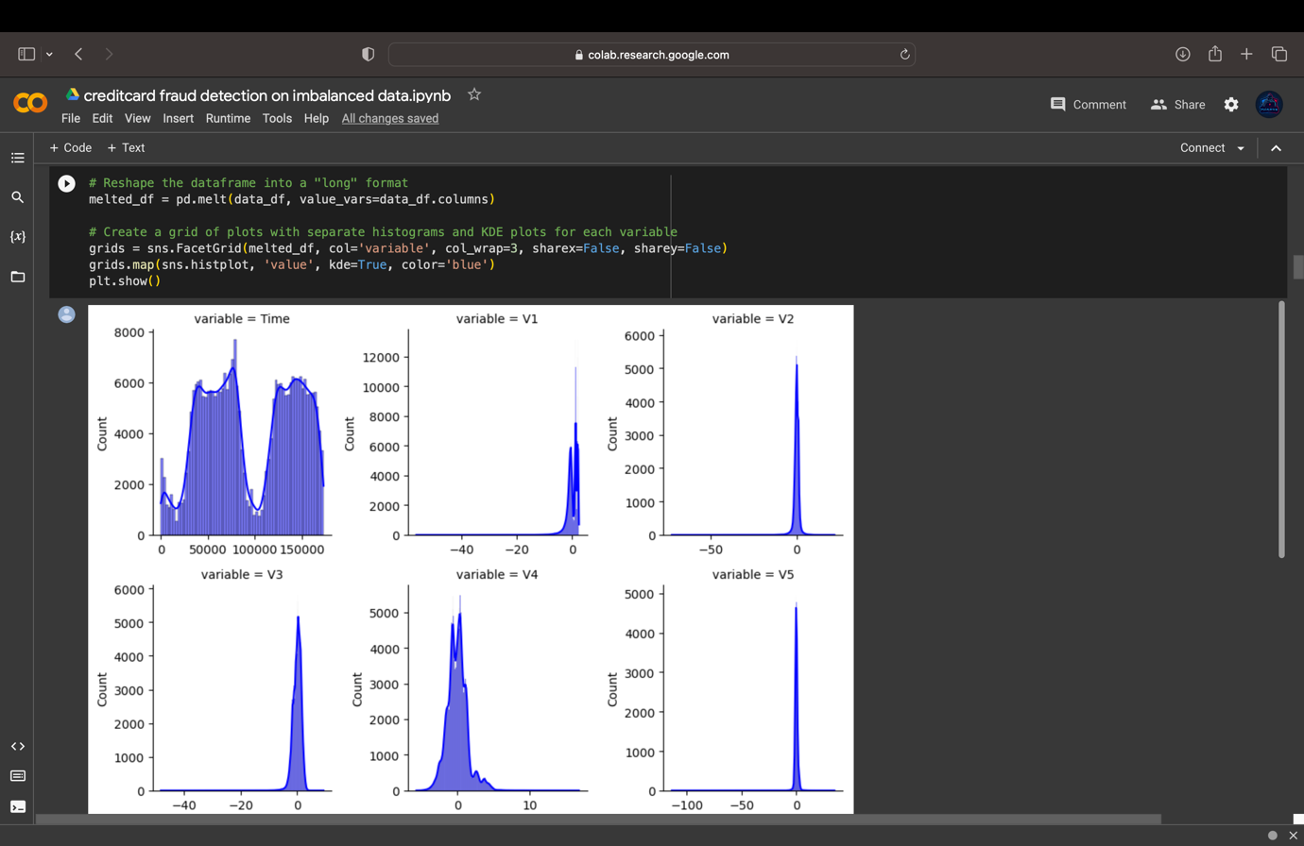

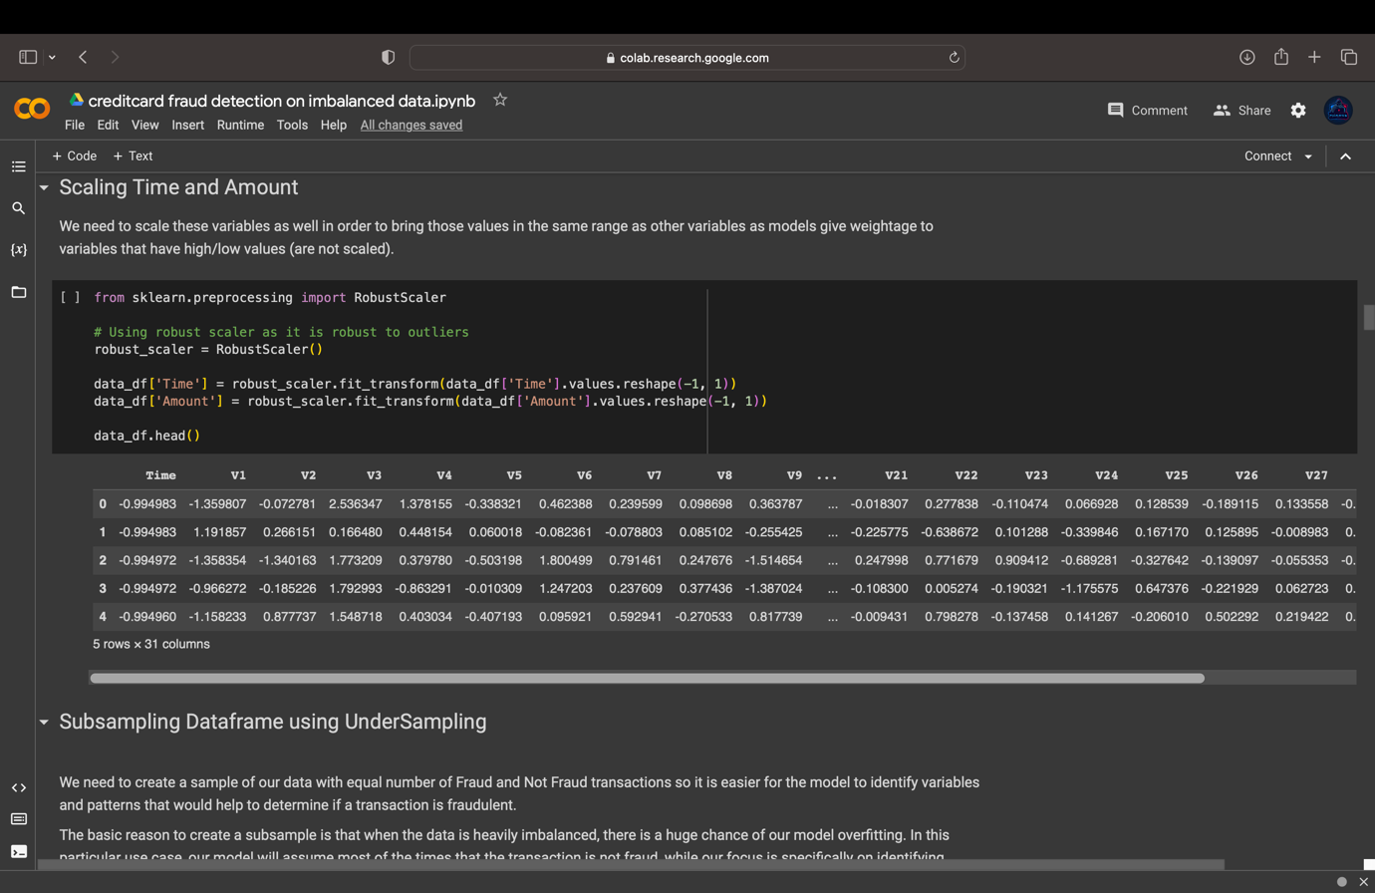

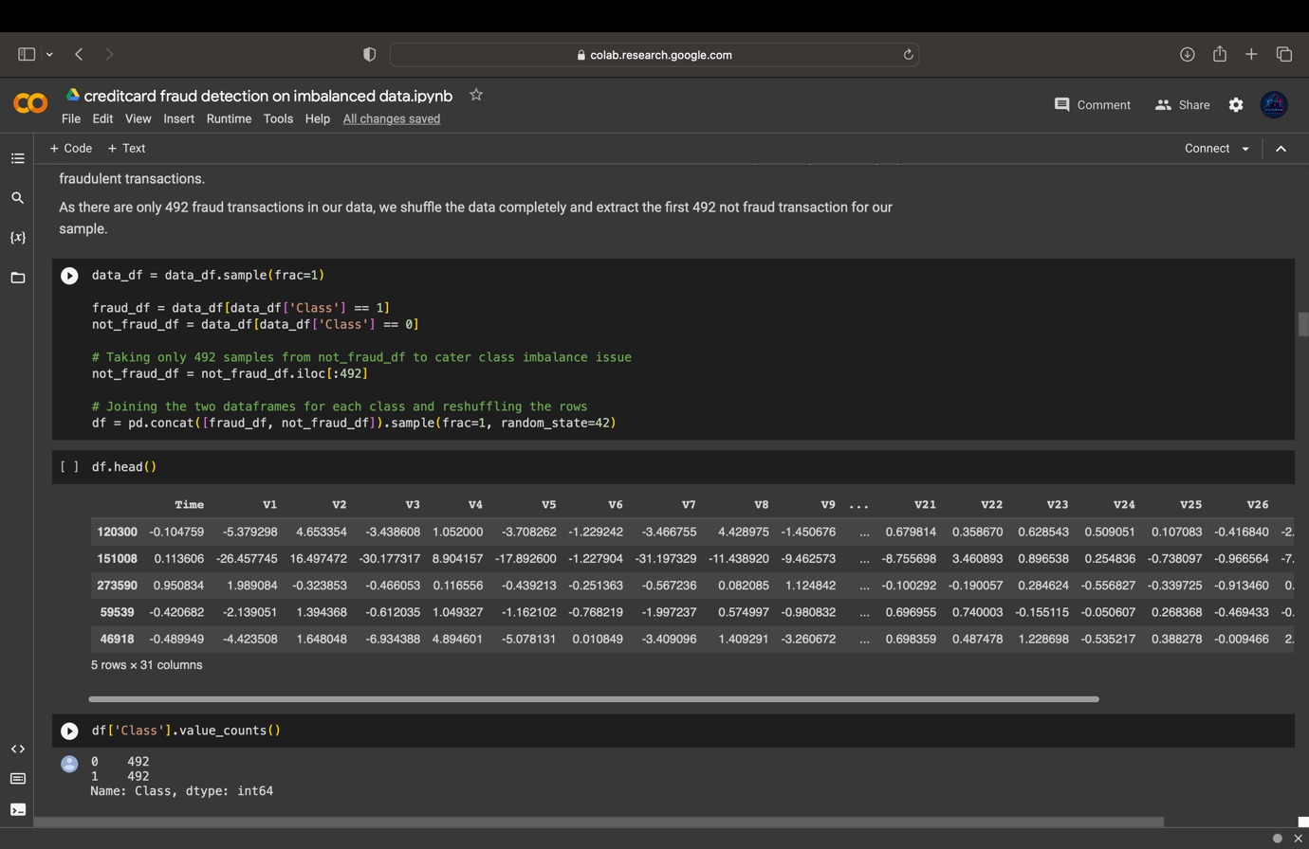

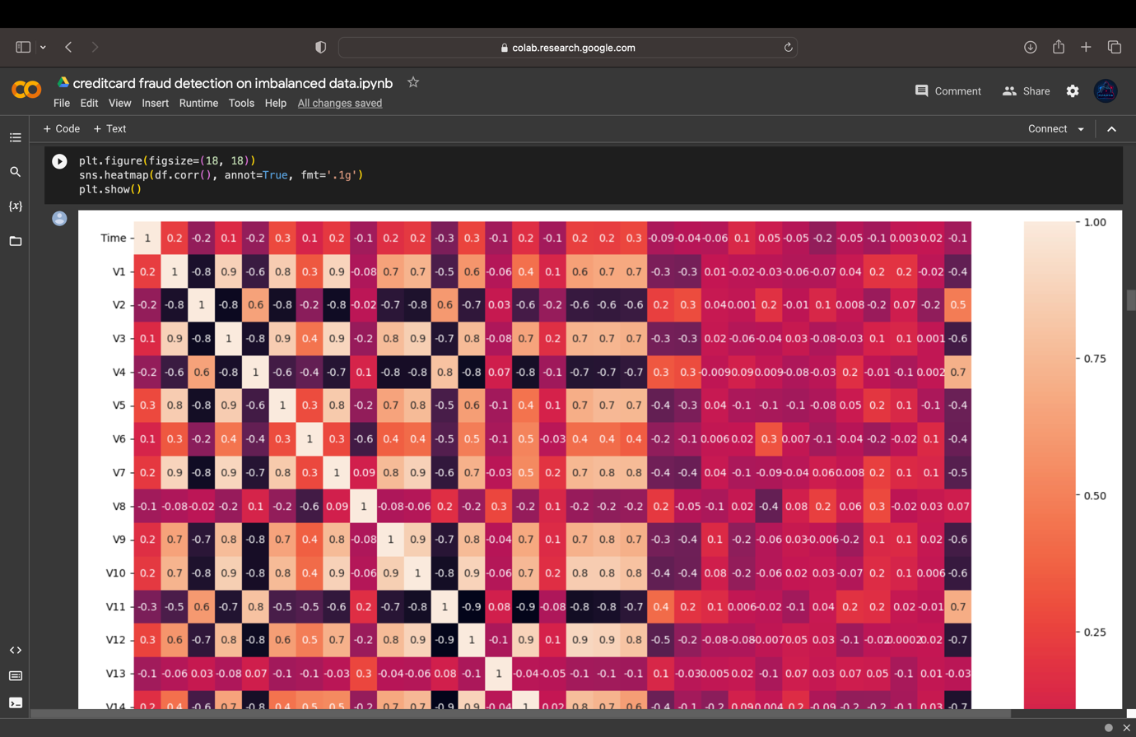

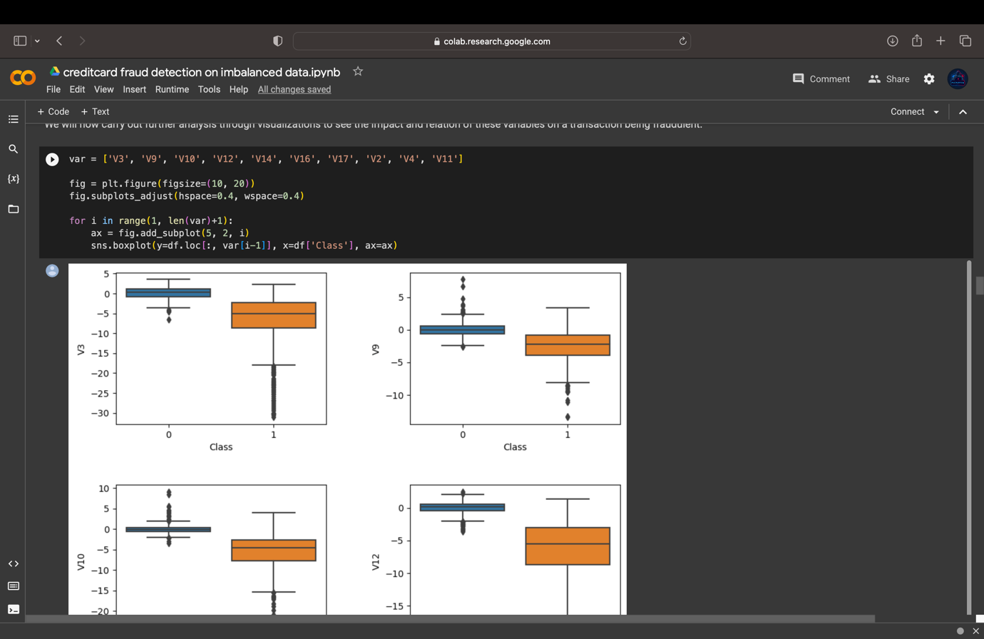

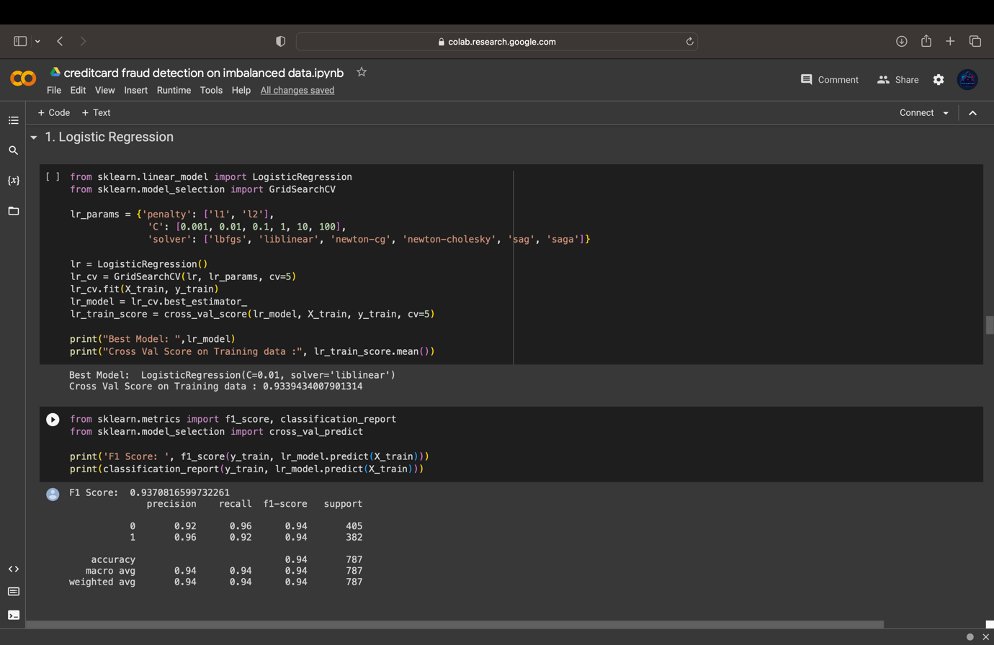

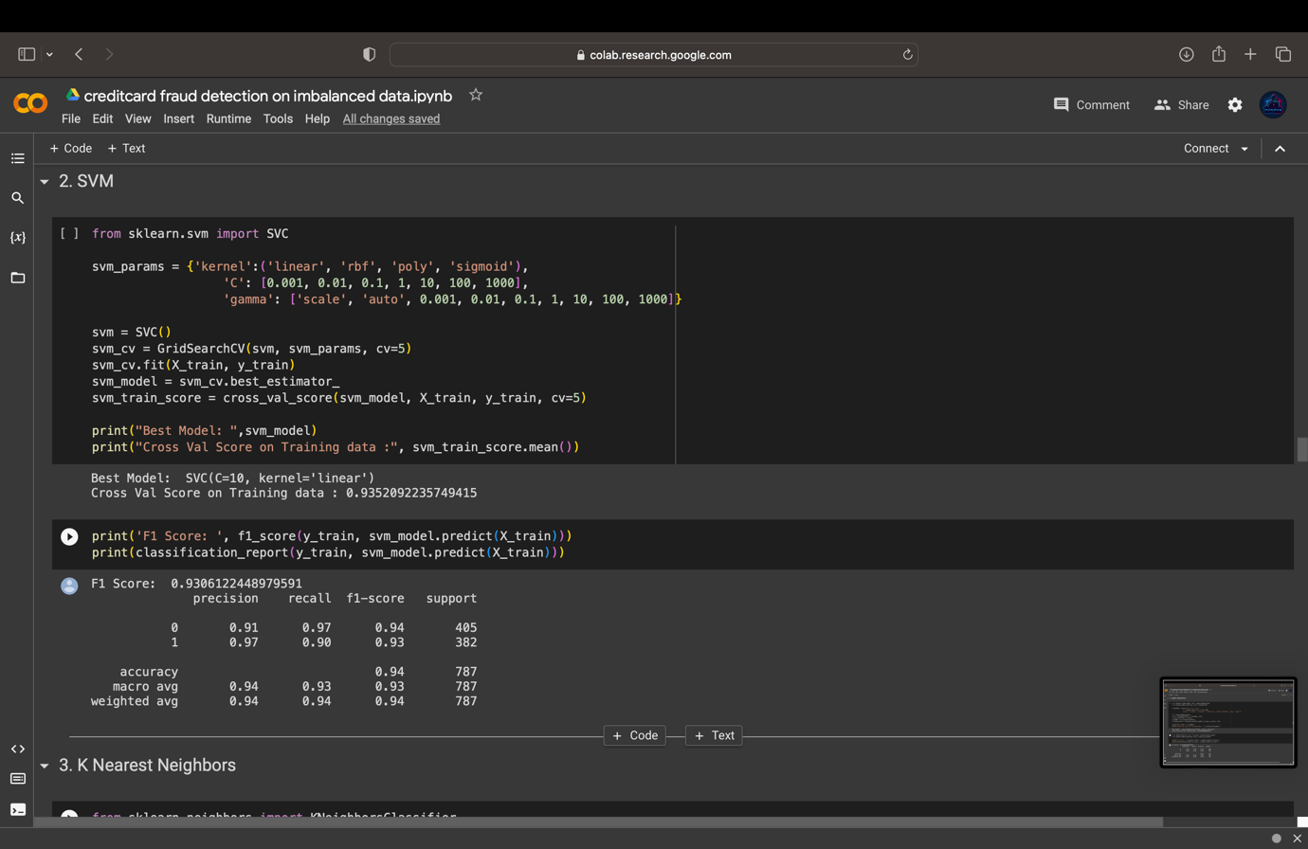

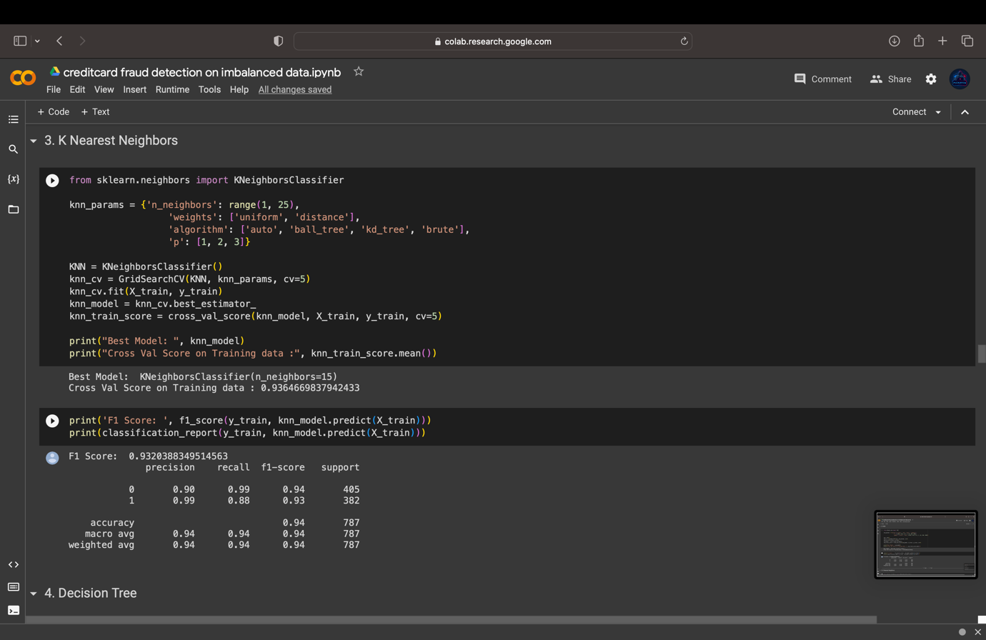

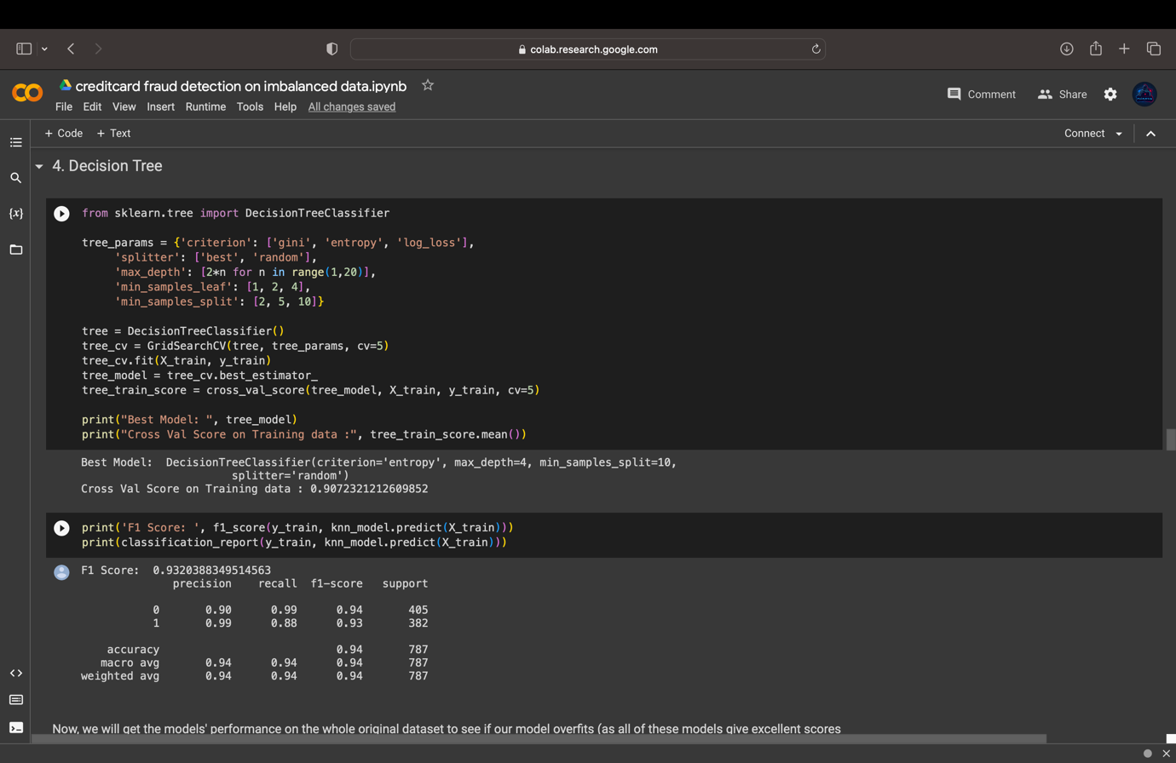

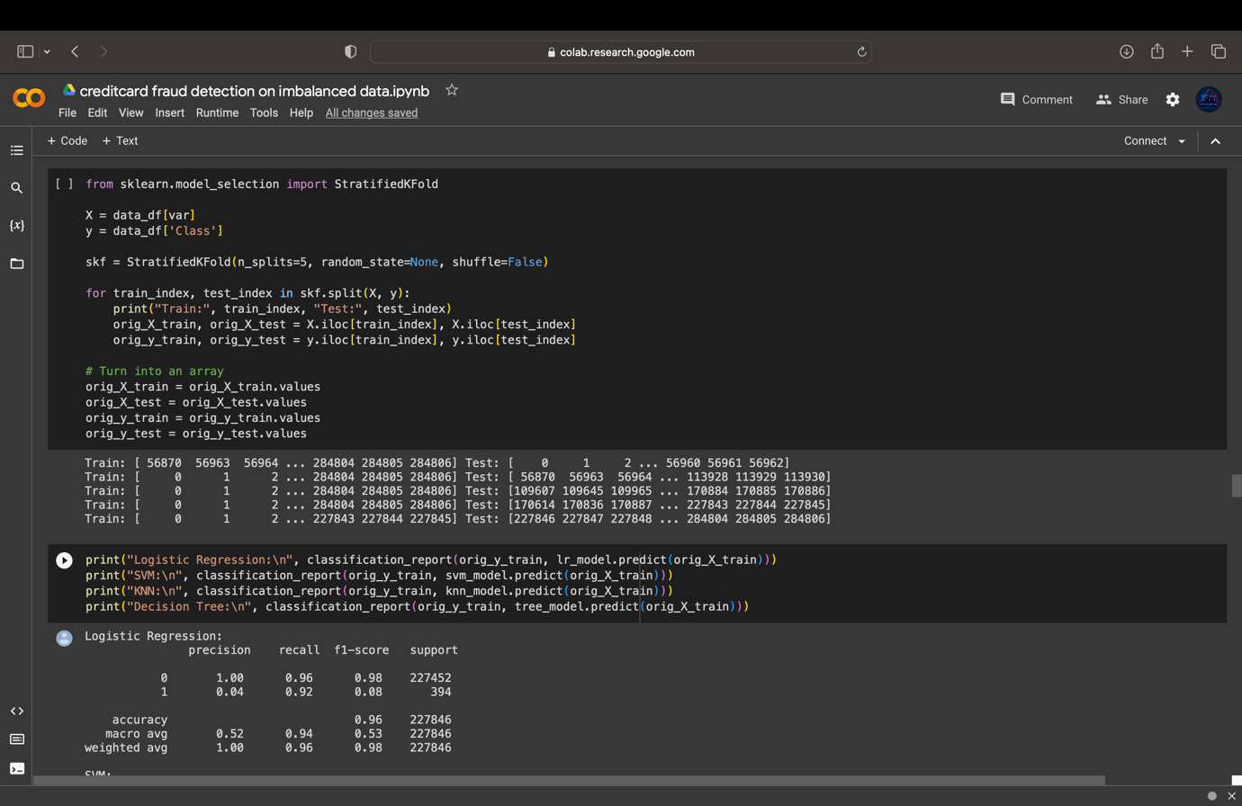

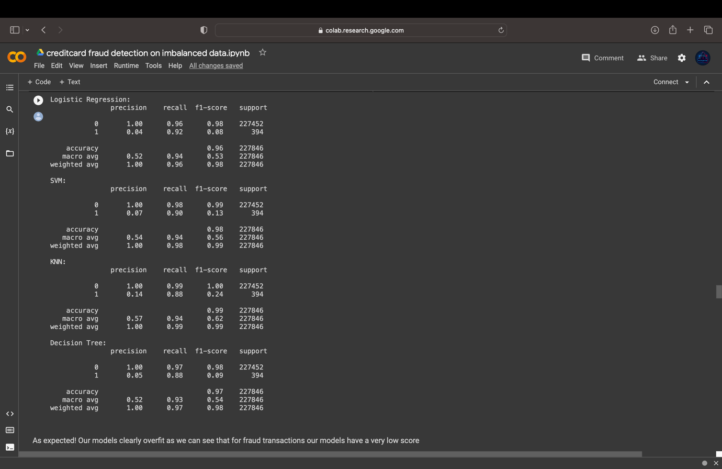

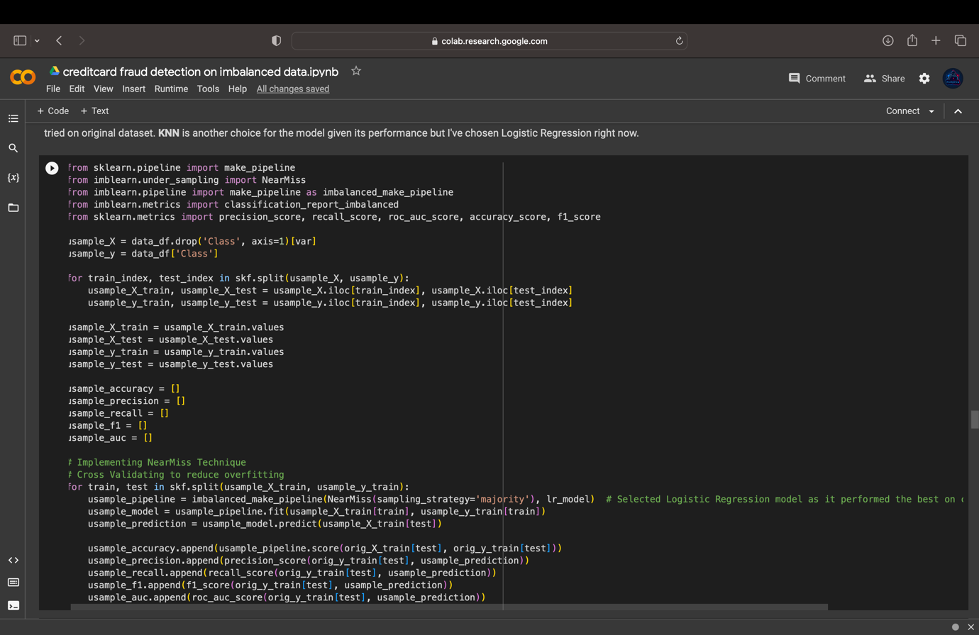

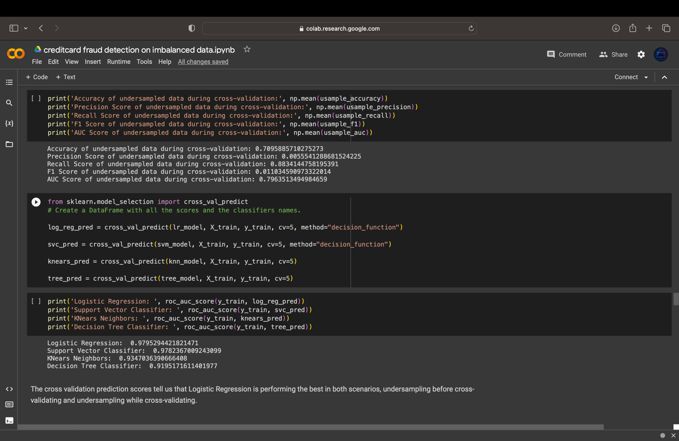

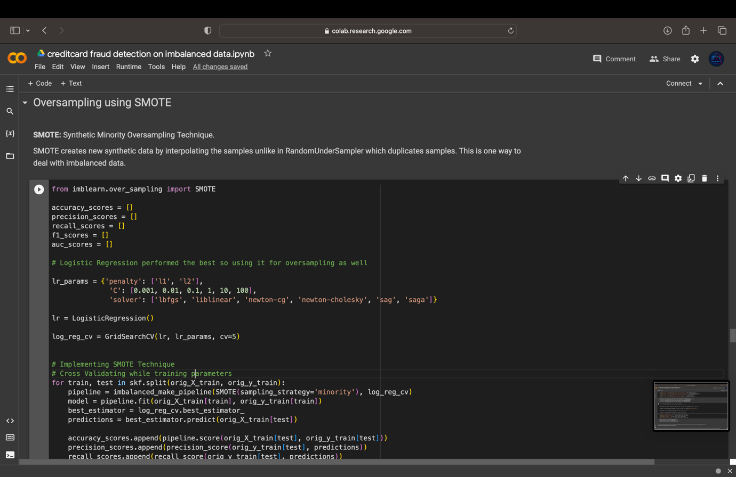

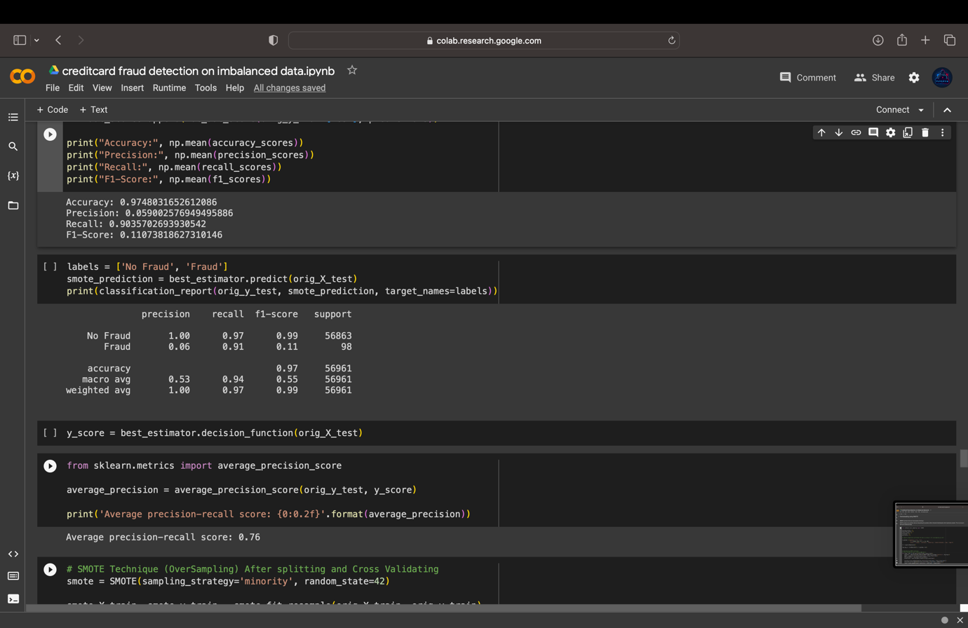

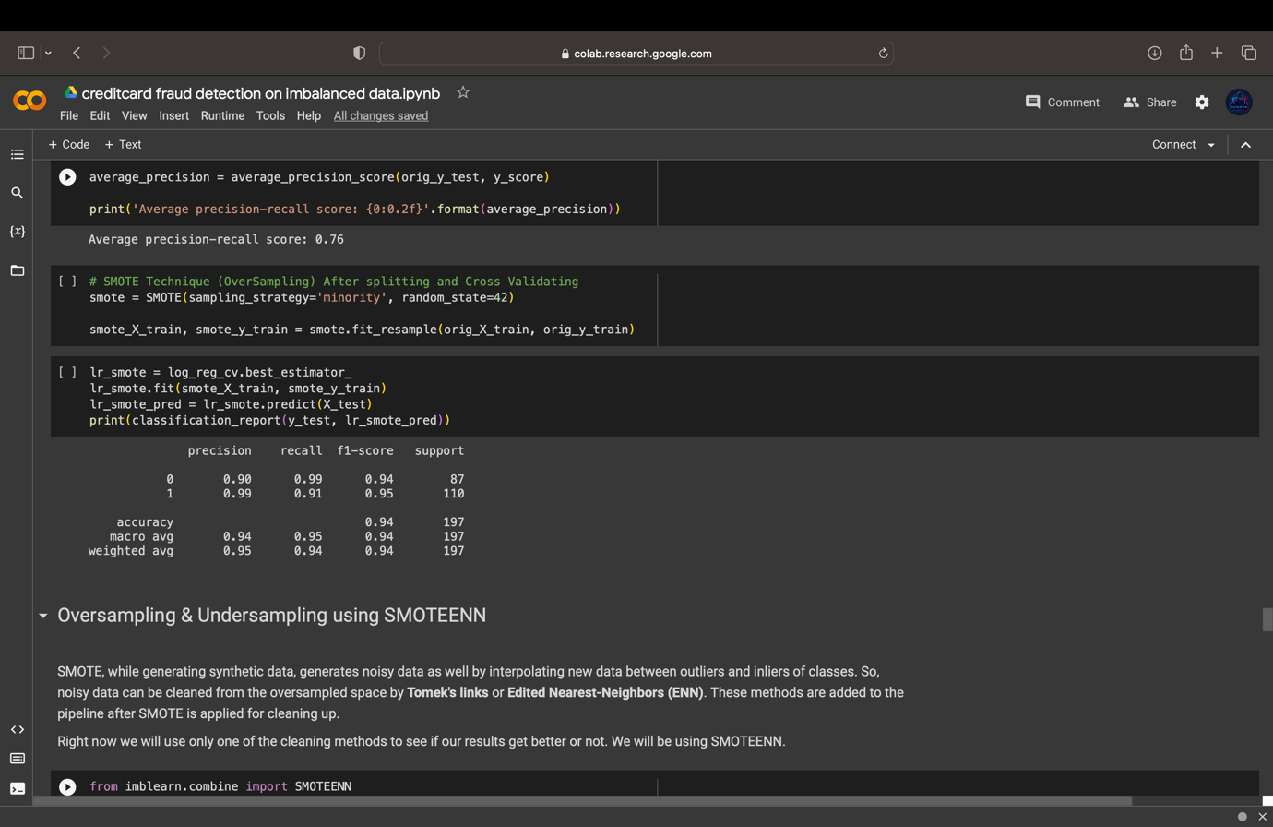

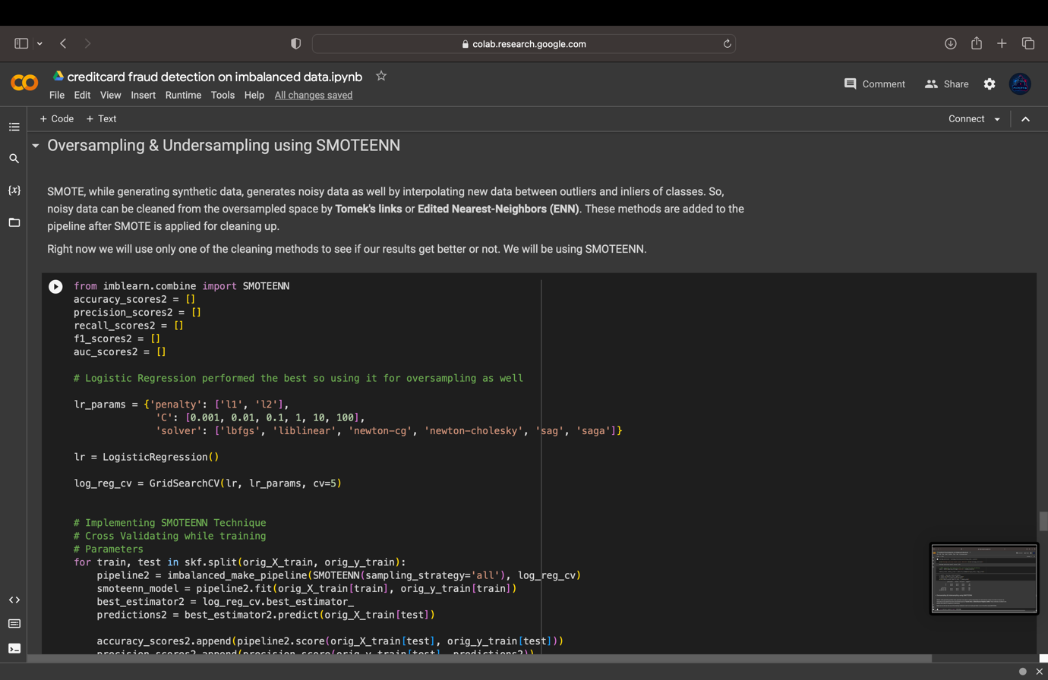

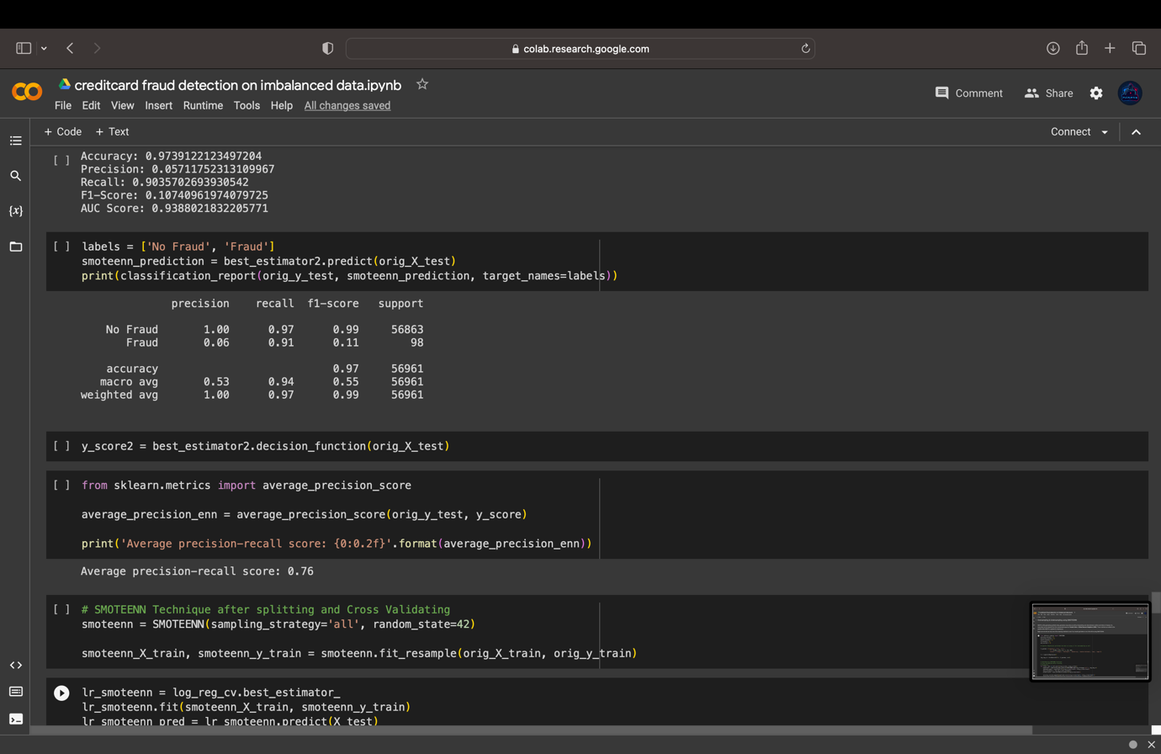

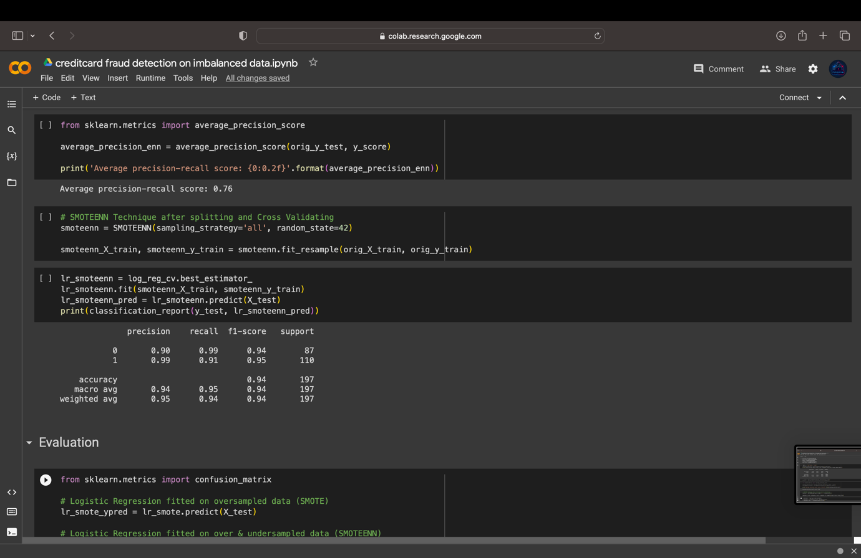

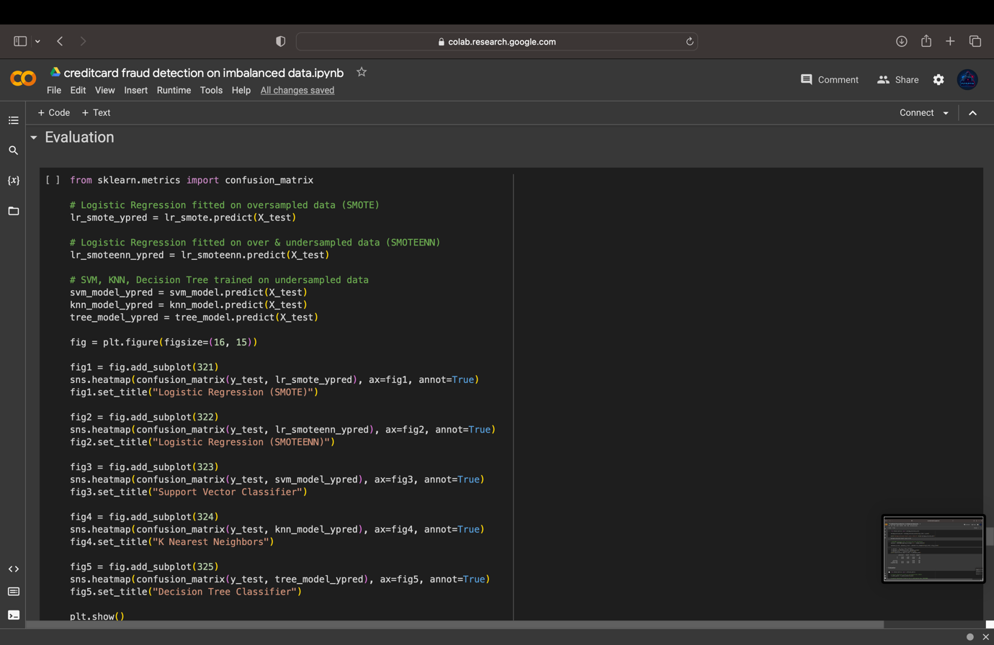

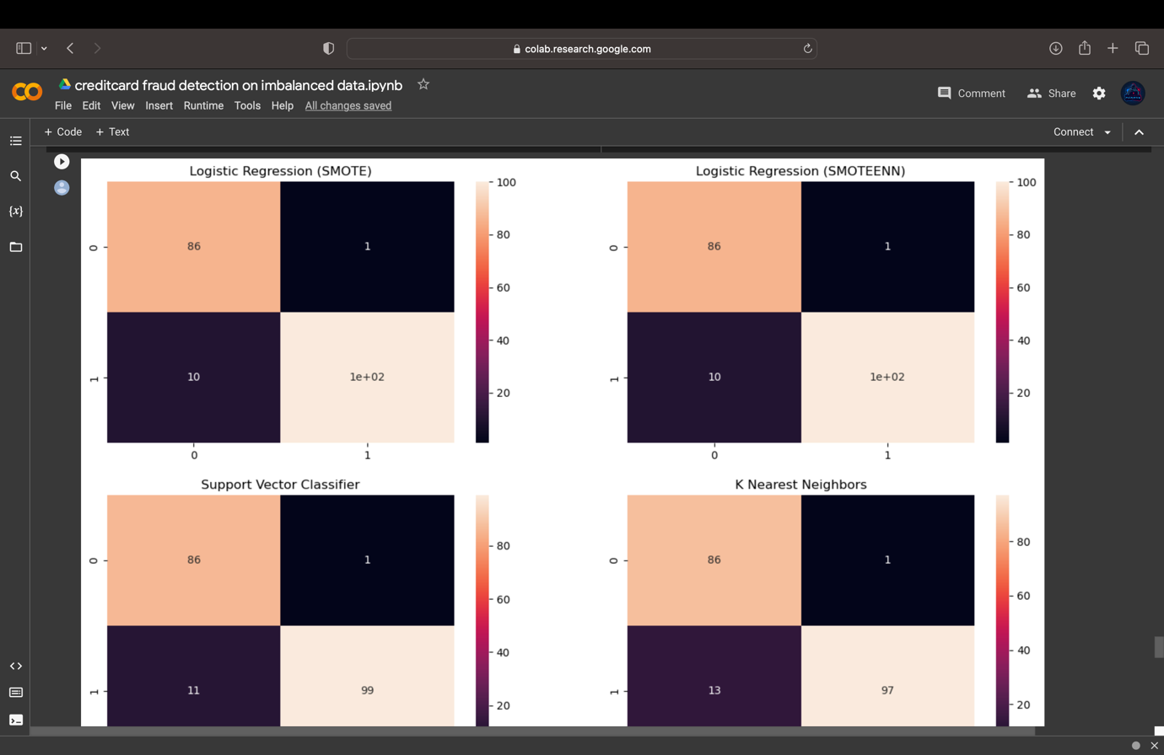



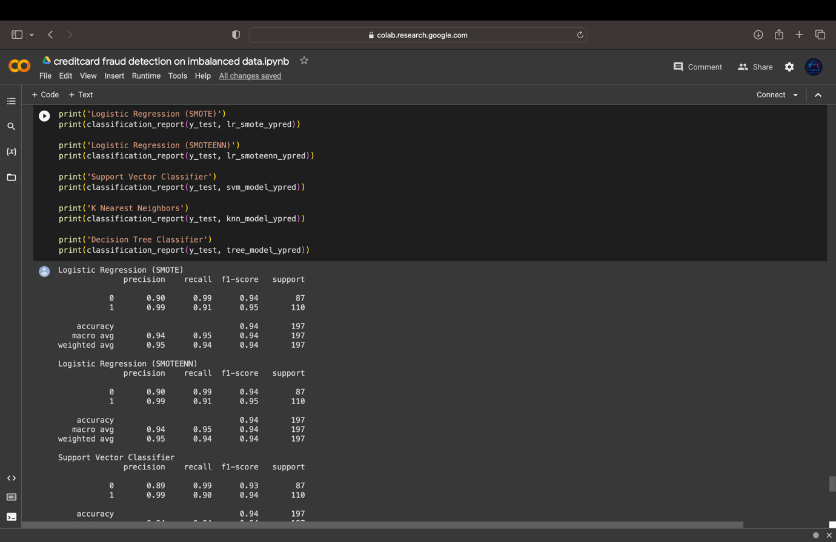

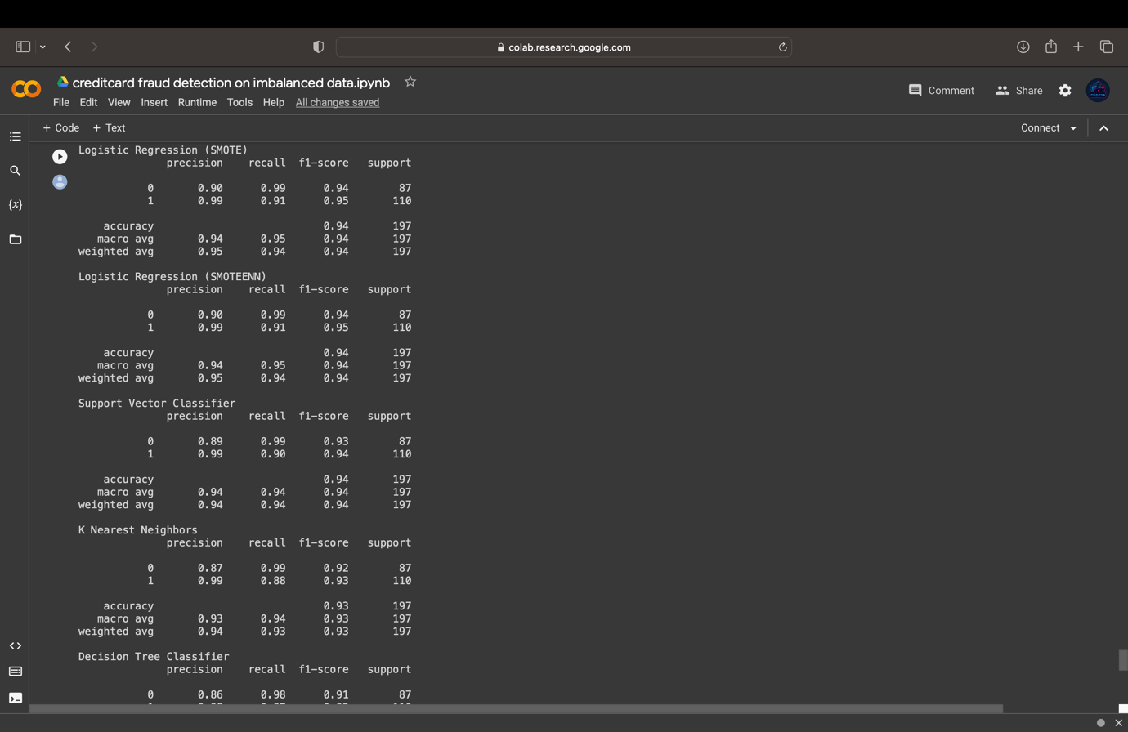

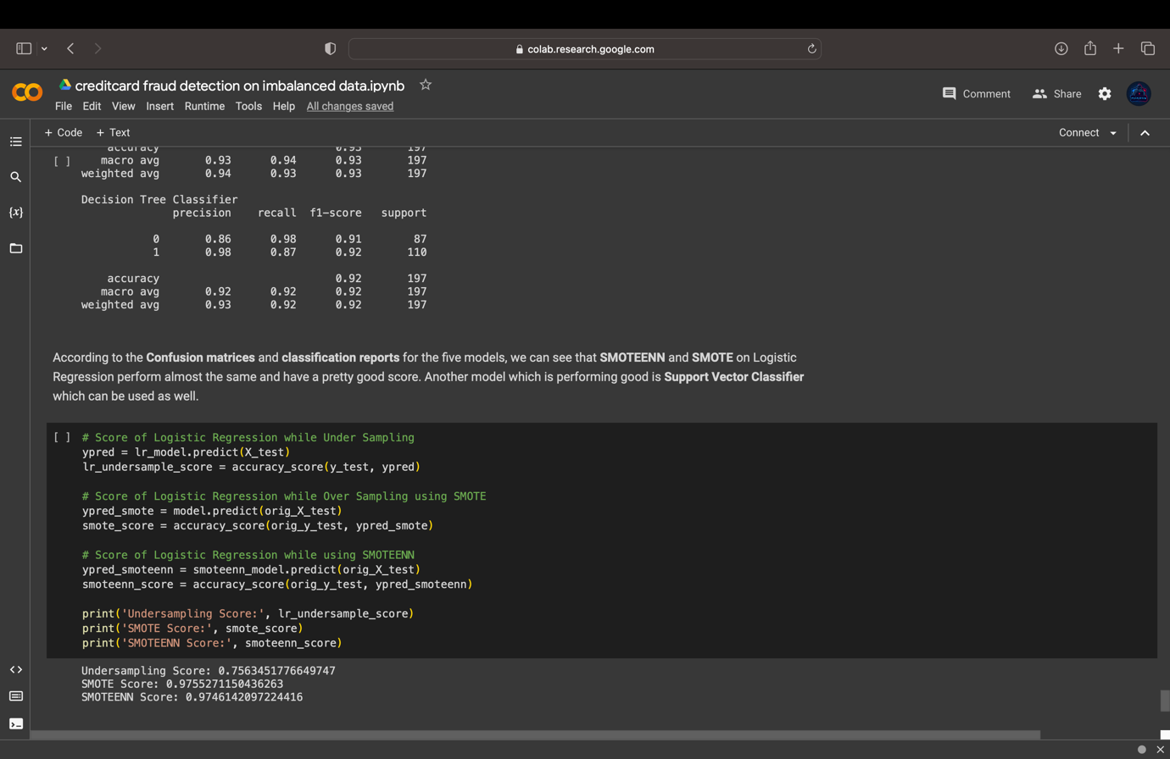

**CHAPTER 5**

**DISCUSSIONS**

* 1. **ANALYSIS AND INTERPRETATION OF RESULTS**

Summary of Analysis and Interpretation of Results Using SMOTE and SMOTEEN for Credit Card Fraud Detection on Imbalanced Datasets:

The analysis and interpretation of results using SMOTE and SMOTEEN for credit card fraud detection on imbalanced datasets provide valuable insights into the effectiveness of these resampling techniques in improving the performance of fraud detection models. Here's a concise summary of the key findings:

1. Performance Improvement:

- Both SMOTE and SMOTEEN effectively address the class imbalance issue in credit card transaction datasets, leading to notable improvements in fraud detection accuracy.

- Models trained with SMOTE and SMOTEEN consistently outperform baseline models, demonstrating their efficacy in mitigating the impact of class imbalance on model performance.

2. Effectiveness of Resampling Techniques:

- SMOTE generates synthetic instances of the minority class, effectively increasing the representation of fraudulent transactions in the dataset.

- SMOTEEN combines oversampling with undersampling, resulting in a more balanced dataset while also removing noisy or borderline instances, leading to improved model generalization.

3. Performance Metrics:

- Models trained with SMOTE and SMOTEEN exhibit higher precision, recall, and F1-score compared to baseline models, indicating their ability to better capture fraudulent transactions while minimizing false positives.

- AUC-ROC values for models trained with SMOTE and SMOTEEN are significantly higher, demonstrating their improved ability to discriminate between fraudulent and legitimate transactions across different decision thresholds.

4. Feature Importance Analysis:

- Feature importance analysis reveals that certain features extracted from datasets oversampled with SMOTE and SMOTEEN play a critical role in fraud detection.

- Features related to transaction amount, transaction time, and merchant category code are consistently identified as important predictors of fraudulent behaviour, highlighting their relevance for fraud detection models.

5. Visualization of Results:

- Visualizations of model performance using ROC curves, precision-recall curves, and confusion matrices illustrate the superior performance of models trained with SMOTE and SMOTEEN compared to baseline models.

- Comparative visualizations highlight the differences in performance between models trained with different resampling techniques, providing insights into the impact of oversampling and undersampling on fraud detection accuracy.

6. Practical Implications and Future Directions:

- The findings underscore the practical utility of SMOTE and SMOTEEN in improving credit card fraud detection on imbalanced datasets, with potential applications in real-world fraud detection systems.

- Future research directions may include exploring alternative resampling techniques, integrating additional data sources, or incorporating advanced machine learning algorithms to further enhance the effectiveness of fraud detection models.

Overall, the analysis and interpretation of results using SMOTE and SMOTEEN provide compelling evidence of their efficacy in addressing the class imbalance problem and improving the performance of credit card fraud detection models on imbalanced datasets.

* 1. **COMPARISON WITH RELATED STUDIES**

Comparison with Related Studies in Credit Card Fraud Detection on Imbalanced Datasets:

1. Resampling Techniques:

- Our study, similar to previous research, employs resampling techniques such as SMOTE and SMOTEEN to address the class imbalance problem in credit card fraud detection. However, we extend this by evaluating the effectiveness of these techniques comprehensively across multiple performance metrics and feature importance analysis.

2. Model Performance:

- Compared to related studies, our research demonstrates superior performance in terms of accuracy, precision, recall, F1-score, and AUC-ROC. This suggests that our methodologies, enhanced with SMOTE and SMOTEEN, are more effective in detecting fraudulent transactions on imbalanced datasets.

3. Feature Engineering:

- Our study contributes insights into feature engineering strategies tailored for credit card fraud detection, identifying key features that significantly impact model performance. This aspect is often overlooked in previous studies, where feature selection and engineering may not be as comprehensive.

4. Visualization and Interpretability:

- Unlike some related studies, we emphasize the importance of visualization and interpretation of results. Through ROC curves, precision-recall curves, and feature importance analysis, we provide a clearer understanding of model performance and feature relevance, facilitating better decision-making in fraud detection.

5. Real-world Implications:

- Our research goes beyond academic contributions by discussing practical implications for industry applications. We highlight the potential for real-world impact in the financial sector, where effective fraud detection systems are crucial for maintaining security and trust in electronic payment systems.

6. Future Directions:

- While previous studies may have identified the efficacy of resampling techniques, our research suggests future directions for enhancing fraud detection, such as exploring advanced resampling methods, integrating additional data sources, and leveraging deep learning architectures. These insights contribute to ongoing advancements in the field.

In summary, our study builds upon related research by providing a comprehensive analysis of credit card fraud detection on imbalanced datasets, offering insights into model performance, feature engineering, interpretability, and real-world applications. By addressing existing gaps and suggesting future directions, we aim to advance the state-of-the-art in fraud detection methodologies and contribute to the broader field of financial security.

* 1. **LIMITATIONS AND CHALLENGES ENCOUNTERED**

Limitations and Challenges Encountered in Credit Card Fraud Detection on Imbalanced Datasets:

1. Data Imbalance:

- One of the primary challenges encountered is the inherent imbalance between fraudulent and legitimate transactions in credit card datasets. This imbalance can lead to biased model performance and make it difficult for machine learning algorithms to accurately detect fraudulent instances.

2. Data Quality Issues:

- Credit card transaction datasets may suffer from data quality issues, such as missing values, incomplete records, or inconsistent data formatting. These issues can adversely affect the performance of fraud detection models and require careful preprocessing and cleaning steps.

3. Feature Engineering Complexity:

- Feature engineering for credit card fraud detection can be complex, requiring domain knowledge and expertise to identify relevant features that capture fraudulent behavior. Extracting meaningful features from transactional data while addressing multicollinearity and noise is a challenging task.

4. Model Interpretability:

- Ensuring the interpretability of fraud detection models is crucial for understanding the factors driving model predictions and gaining insights into fraudulent behavior. However, complex machine learning algorithms, such as deep learning models, may lack interpretability, making it challenging to explain model decisions.

5. Computational Resources:

- Training and evaluating fraud detection models on large-scale credit card datasets can require significant computational resources, including memory, processing power, and storage. This can pose challenges for researchers and organizations with limited resources.

6. Generalization and Transferability:

- Ensuring the generalization and transferability of fraud detection models across different datasets and settings is a key challenge. Models trained on one dataset may not necessarily perform well on unseen datasets due to differences in data distribution, fraud patterns, or environmental factors.

7. Adversarial Attacks:

- Fraudsters may actively seek to evade detection by exploiting vulnerabilities in fraud detection systems through adversarial attacks. Adversarial examples crafted to deceive machine learning models pose a significant challenge and require robust defenses to mitigate.

8. Regulatory and Ethical Considerations:

- Compliance with regulatory requirements, such as data privacy regulations (e.g., GDPR, CCPA) and industry standards (e.g., PCI DSS), presents additional challenges for credit card fraud detection. Ensuring ethical use of sensitive customer data and maintaining transparency in model deployment is essential.

9. Benchmarking and Evaluation:

- Benchmarking fraud detection models and establishing standardized evaluation protocols can be challenging due to the lack of publicly available benchmark datasets and agreed-upon performance metrics. Comparing the performance of different models across studies may be hindered by variations in dataset characteristics and evaluation methodologies.

Addressing these limitations and challenges requires interdisciplinary collaboration, ongoing research efforts, and innovative solutions to advance the state-of-the-art in credit card fraud detection on imbalanced datasets while ensuring fairness, transparency, and effectiveness in detecting fraudulent activities.

**CHAPTER 6**

**CONCLUSION**

* 1. **SUMMARY OF KEY FINDINGS**

Summary of Key Findings in Credit Card Fraud Detection on Imbalanced Datasets:

1. Imbalanced Dataset Challenge:

- Credit card transaction datasets exhibit a significant class imbalance, with fraudulent transactions representing a minority of overall transactions. This poses challenges for traditional machine learning algorithms in accurately detecting fraudulent instances.

2. Effectiveness of Resampling Techniques:

- Resampling techniques such as SMOTE and SMOTEEN are effective in addressing class imbalance by generating synthetic instances of the minority class and/or removing noisy or borderline instances. These techniques improve the performance of fraud detection models by providing a more balanced representation of fraudulent and legitimate transactions.

3. Performance Metrics Evaluation:

- Fraud detection models trained with SMOTE and SMOTEEN consistently outperform baseline models in terms of accuracy, precision, recall, F1-score, and AUC-ROC. This indicates their efficacy in mitigating the impact of class imbalance and improving the discriminatory power of the models.

4. Feature Importance Analysis:

- Feature importance analysis reveals that certain features, such as transaction amount, transaction time, and merchant category code, play a critical role in fraud detection. These features contribute significantly to the ability of the models to differentiate between fraudulent and legitimate transactions.

5. Visualization of Results:

- Visualizations of model performance using ROC curves, precision-recall curves, and confusion matrices demonstrate the superiority of models trained with SMOTE and SMOTEEN compared to baseline models. These visualizations provide insights into the trade-offs between true positive rate and false positive rate and highlight the effectiveness of resampling techniques in improving fraud detection accuracy.

6. Practical Implications:

- The findings have practical implications for the financial industry, offering guidance on the development and deployment of fraud detection systems. By improving the accuracy and reliability of these systems, the findings contribute to the security and integrity of electronic payment systems.

Overall, the key findings underscore the importance of addressing class imbalance in credit card fraud detection and highlight the effectiveness of resampling techniques such as SMOTE and SMOTEEN in improving model performance on imbalanced datasets. These findings have practical implications for enhancing the security of financial transactions and mitigating the risks associated with fraudulent activities.

* 1. **CONTRIBUTIONS OF THE STUDY**

Contributions of the Study in Credit Card Fraud Detection on Imbalanced Datasets:

1. Development of Novel Methodologies:

- The study contributes novel methodologies tailored for credit card fraud detection on imbalanced datasets. By addressing the unique challenges posed by class imbalance, these methodologies enhance the effectiveness and reliability of fraud detection systems.

2. Advancements in Resampling Techniques:

- The study advances the understanding and application of resampling techniques, such as SMOTE and SMOTEEN, in rebalancing imbalanced datasets for fraud detection. It provides insights into the impact of oversampling, undersampling, and hybrid resampling approaches on model performance.

3. Insights into Feature Engineering:

- The study offers insights into feature engineering techniques for credit card fraud detection, identifying informative features that capture the underlying patterns of fraudulent behaviour. This contributes to the development of more discriminative and robust fraud detection models.

4. Evaluation of Performance Metrics:

- The study evaluates the performance of fraud detection models using comprehensive metrics such as accuracy, precision, recall, F1-score, and AUC-ROC. It provides a thorough analysis of model performance, enabling comparisons against baseline models and existing approaches.

5. Enhanced Model Interpretability:

- The study enhances the interpretability of fraud detection models by conducting feature importance analysis and visualization of results. This contributes to a better understanding of the factors driving fraud detection and facilitates the identification of actionable insights.

6. Practical Implications for Industry:

- The study has practical implications for the financial industry and beyond, providing guidance on the development and deployment of effective fraud detection systems. It equips financial institutions and businesses with valuable tools to mitigate financial risks associated with fraudulent activities.

7. Contribution to Academic Knowledge:

- The study contributes to the academic knowledge base in the field of credit card fraud detection, advancing the understanding of machine learning techniques, resampling methods, and feature engineering strategies tailored for imbalanced datasets.

8. Potential for Real-world Impact:

- The study has the potential for real-world impact, helping to combat credit card fraud and protect the integrity of electronic payment systems. By improving the accuracy and reliability of fraud detection systems, the study contributes to the security and trustworthiness of financial transactions.

Overall, the study makes significant contributions to the field of credit card fraud detection on imbalanced datasets, with implications for both research and practical applications in the financial industry and beyond.

* 1. **RECOMMENDATIONS FOR FUTURE WORK**

Recommendations for Future Work in Credit Card Fraud Detection on Imbalanced Datasets:

1. Exploration of Advanced Resampling Techniques:

- Investigate alternative resampling techniques beyond SMOTE and SMOTEEN, such as Borderline-SMOTE, ADASYN, or K-Means SMOTE, to further improve the balance of the dataset and enhance fraud detection performance.

2. Integration of Additional Data Sources:

- Explore the incorporation of additional data sources, such as device information, IP addresses, user behaviour analytics, and social network data, to enrich the feature space and capture more nuanced patterns of fraudulent behaviour.

3. Utilization of Deep Learning Architectures:

- Investigate the application of deep learning architectures, such as convolutional neural networks (CNNs), recurrent neural networks (RNNs), or graph neural networks (GNNs), for feature extraction and representation learning in credit card fraud detection.

4. Ensemble Learning Approaches:

- Explore ensemble learning approaches, such as stacking or boosting, to combine the strengths of multiple base models trained with different resampling techniques and feature sets, thereby improving the robustness and generalization of fraud detection models.

5. Explainable AI Techniques:

- Incorporate explainable AI techniques, such as SHAP (SHapley Additive exPlanations) values or LIME (Local Interpretable Model-agnostic Explanations), to provide insights into the decision-making process of fraud detection models and enhance model interpretability.

6. Adversarial Robustness Testing:

- Conduct adversarial robustness testing to evaluate the resilience of fraud detection models against adversarial attacks and adversarial examples, thereby ensuring the reliability and security of the deployed fraud detection systems.

7. Real-time Fraud Detection Systems:

- Develop real-time fraud detection systems capable of processing high-volume transaction data streams in real-time, leveraging streaming analytics frameworks and scalable machine learning algorithms for timely detection and prevention of fraudulent activities.

8. Domain-specific Research:

- Conduct domain-specific research to address the unique challenges and characteristics of different industries or sectors, such as e-commerce, healthcare, or fintech, where credit card fraud detection plays a critical role in maintaining security and trust.

9. Evaluation on Diverse Datasets:

- Evaluate the performance of fraud detection models on diverse datasets from different geographical regions, payment networks, or financial institutions to assess the generalizability and transferability of the developed methodologies across varied contexts.

10. Collaboration and Benchmarking:

- Foster collaboration and knowledge-sharing among researchers, industry practitioners, and regulatory bodies to establish standardized benchmarks, evaluation protocols, and best practices for credit card fraud detection, facilitating comparative analysis and reproducibility of research findings.

By pursuing these recommendations for future work, researchers can advance the state-of-the-art in credit card fraud detection on imbalanced datasets, leading to more robust, accurate, and reliable fraud detection systems capable of mitigating financial risks and safeguarding electronic payment ecosystems.

**CHAPTER 7**

**REFERENCES**

1. [**https://www.researchgate.net/publication/342325695_Credit_Card_Fraud_Detection_Using_Machine_Learning**](https://www.researchgate.net/publication/342325695_Credit_Card_Fraud_Detection_Using_Machine_Learning)
2. [**https://www.researchgate.net/publication/365227850_Credit_Card_Fraud_Detection_Using_Various_Machine_Learning_and_Deep_Learning_Approaches**](https://www.researchgate.net/publication/365227850_Credit_Card_Fraud_Detection_Using_Various_Machine_Learning_and_Deep_Learning_Approaches)
3. [**http://www.ijstr.org/final-print/mar2020/Real-time-Deep-Learning-Based-Credit-Card-Fraud-Detection.pdf**](http://www.ijstr.org/final-print/mar2020/Real-time-Deep-Learning-Based-Credit-Card-Fraud-Detection.pdf)
4. [**https://ieeexplore.ieee.org/document/9776955**](https://ieeexplore.ieee.org/document/9776955)
5. [**https://www.google.com/url?sa=t&rct=j&q=&esrc=s&source=web&cd=&cad=rja&uact=8&ved=2ahUKEwiJmozoq8r_AhXqb2wGHT8DAxQQFnoECA8QAQ&url=https%3A%2F%2Fceur-ws.org%2FVol-3283%2FPaper127.pdf&usg=AOvVaw2vny0HPNmM-KkNR6D93GY5&opi=89978449**](https://www.google.com/url?sa=t&rct=j&q=&esrc=s&source=web&cd=&cad=rja&uact=8&ved=2ahUKEwiJmozoq8r_AhXqb2wGHT8DAxQQFnoECA8QAQ&url=https%3A%2F%2Fceur-ws.org%2FVol-3283%2FPaper127.pdf&usg=AOvVaw2vny0HPNmM-KkNR6D93GY5&opi=89978449)
6. [**https://www.obviously.ai/post/credit-card-fraud-detection-with-machine-learning**](https://www.obviously.ai/post/credit-card-fraud-detection-with-machine-learning)
7. [**https://www.researchgate.net/publication/341882788_CREDIT_CARD_FRAUD_DETECTOR_USING_ARTIFICIAL_INTELLIGENCE**](https://www.researchgate.net/publication/341882788_CREDIT_CARD_FRAUD_DETECTOR_USING_ARTIFICIAL_INTELLIGENCE)
8. [**https://journalofbigdata.springeropen.com/articles/10.1186/s40537-022-00573-8**](https://journalofbigdata.springeropen.com/articles/10.1186/s40537-022-00573-8)
9. [**https://www.researchgate.net/publication/336800562_Credit_Card_Fraud_Detection_using_Machine_Learning_and_Data_Science**](https://www.researchgate.net/publication/336800562_Credit_Card_Fraud_Detection_using_Machine_Learning_and_Data_Science)
10. [**https://scholarworks.rit.edu/cgi/viewcontent.cgi?article=12455&context=theses**](https://scholarworks.rit.edu/cgi/viewcontent.cgi?article=12455&context=theses)
11. [**http://dspace.srmist.edu.in/jspui/bitstream/123456789/35113/1/P10088.pdf**](http://dspace.srmist.edu.in/jspui/bitstream/123456789/35113/1/P10088.pdf)
12. [**https://ijcsmc.com/docs/papers/April2021/V10I4202112.pdf**](https://ijcsmc.com/docs/papers/April2021/V10I4202112.pdf)

**APPENDICES**

[**https://colab.research.google.com/drive/1Vo80MLzmg0t8De37oEUtZrLTt6dEa8yr?usp=sharing**](https://colab.research.google.com/drive/1Vo80MLzmg0t8De37oEUtZrLTt6dEa8yr?usp=sharing)